TABLE OF CONTENTS
Mission, Vision, Warranty, Special Order Information (2)
Special Spindle Order Form (3)
G.E.P. Positive And Negative Offset Information (4)

AGRICULTURAL HUBS

- Bolt, 5” Bolt Circle, 3.62"Pilot. (6-8)
- Bolt, 5.5” Bolt Circle, 4” Pilot. (9-11)
- Bolt, 6” Bolt Circle, 4.62” Pilot. (12-18)
8-Bolt, 8” Bolt Circle, 6” Pilot. (19-26)
10-Bolt, 11.25” Bolt Circle, 8.69” Pilot. (27)
10-Bolt, 11.25” Bolt Circle, 8.62” Pilot (28)
10-Bolt, 13.19” Bolt Circle, 11.02” Pilot. (29-31)
20-Bolt, 20.125” Bolt Circle, 17.865” Pilot. (32)

RECREATIONAL VEHICLE (RV) HUBS
4-Bolt, 4” Bolt Circle, 2.5” Pilot (34)
5-Bolt, 4.5” Bolt Circle, 2.5” Pilot (35)
5-Bolt, 4.5”/5” Bolt Circle, 2.5” Pilot (36)
6 Bolt, 5.50" Bolt Circle, 3.55” Pilot (37)
- Bolt, 6.50" Bolt Circle, 4.55” Pilot (37)

SPECIALTY HUBS
Military Hub. (39)
Coulter Hubs (40)
Sealer, Row Marker Hubs (41)
Hay Rake Hubs. (42)
Straddle Hubs (43)
Tail Wheel Hubs (44)

Hub And Spindle Components (45-50)
Segmented Tires (51)
Coulters and Coulter Disc Blades (52-53)
Agricultural Jacks (54-55)

MISSION STATEMENT
Our Mission is to provide quality machined agricultural products timely, professionally, and at very competitive pricing.

VISION
Our Vision is to be a leader in hub, spindle, and coulter manufacturing for Agriculture applications by providing top quality products and innovative designs.

WARRANTIES AND CAPACITIES
Hub capacities, as stated in our catalog, reflect the standard load ratings as established and accepted throughout the industry, which are based on 20 MPH maximum speeds. GEP products are intended for use in free rolling applications. Capacities may be reduced and warranty voided when used as driven wheels, power steering, tandem and walking beam axles, hillside operations, rough terrains, high centers of gravity, or excessive speed.
GEP offers hubs and components which exceed the highest standards in the industry. GEP warrants their products to be free of defects in workmanship and material for normal use and services for one year from shipping date.
GEP’s obligation under this warranty is limited to the repair or replacement of the defective hub and its components, and is not liable for any incidental or consequential damages to property or persons, including any accruing costs (i.e. towing fees, hotel expenses, and meals).

SPECIAL ORDER POLICY
Our Special Order Policy covers those items not conforming to standard catalog products, including parts made to custom specifications.
Change orders covering quantity or specification changes must be approved in writing by GEP before parts are manufactured. Any changes received after production of parts may be approved, if practical; otherwise customer is responsible for the original quantity and design.
Hubs marked “Special Order” in this catalog may be available with a minimum quantity order and extended lead-time. They are not a stock item.

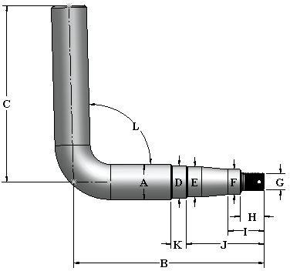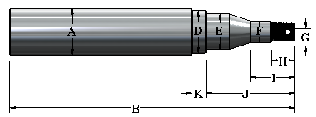SPECIAL SPINDLE ORDER FORM

MATERIAL SPECIFICATION | ROLL STYLE | DIAMETER | MATERIAL
Standard Material | CRS | 1" - 1-5/8" | 1018
Standard Material | CRS | 1-3/4" - 4-1/2" | 1045
Special Order | CRS | 2" - 6" | 1141
Special Order | CRS | 2" - 6" | 1144
Special Order | HTSR | 3" - 7" | 4140

IMPORTANT SPINDLE INFORMATION

SPINDLE STYLES
L: Straight Length DL: Duel End Length BL: Bent Length
GEP offers a large selection of machined spindles in straight (up to 7”), bent (up to 3”), or double ended to meet your requirements. Our capabilities also include milling keyways, drilling cross holes, and thread tapping.
Please feel free to contact GEP regarding information on our additional machining capabilities.

 | DIMENSIONS
Customer Name: | A |  | G
Hub Number: | B |  | H
Spindle Style: | C |  | I
Dimensions: | D |  | J
Cross Hole Dia. & Location: | E |  | K
Comments: | F |  | L
For Example: From The Spindle Section Of Catalog Page, Use First Six Digits Of Spindle Number. Followed By The Letter (L) And Your Desired Spindle Length. Part # G280700L10.375 Is A 10.375" Long Spindle For A G633 Hub.

OFFSET INFORMATION
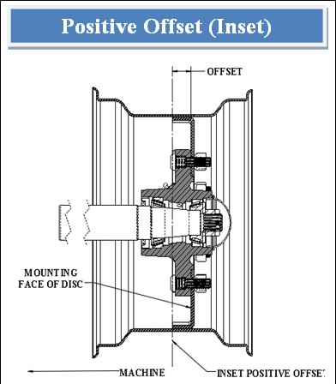
Positive Offset (Inset)
Inset is the distance between the mounting face of the disc and the rim centerline. This distance is termed positive when the mounting face is outboard of the rim centerline.

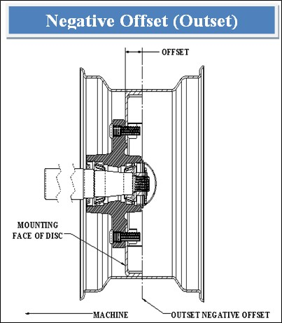
Negative Offset (Outset)
Outset is the distance between the mounting face of the disk and the rim centerline. This distance is termed negative when the mounting face is inboard of the rim centerline.

DEFINITION OF OFFSETS AND BOLT HOLE CIRCLES

  - What is an Offset?
The difference between the rim centerline and the vertical mounting face of the hub flange.
  - What is a Bolt Circle diameter?
The bolt circle diameter is the nominal diameter at which the bolt holes are located on the flange of the hub.
  - What is a Bolt Hole Specification?
A bolt hole specification is the diameter and shape of the hole to accept specific type of studs or wheel bolts. Example 60°, 90°, coin, flat, double spherical countersink, etc.
  - What is the Capacity?
The load rating given to a hub is based on how much weight a hub can handle under load and traveling at a 20 M.P.H. maximum speed. The capacity of a hub can adversely be affected by the center of gravity or an improper rim offset.
  - What is a Pilot?
The pilot is the inside diameter of the center hole of a rim/ wheel. The pilot is used to guide the rim/wheel on to the hub for installation.

AGRICULTURAL AND INDUSTRIAL HUBS

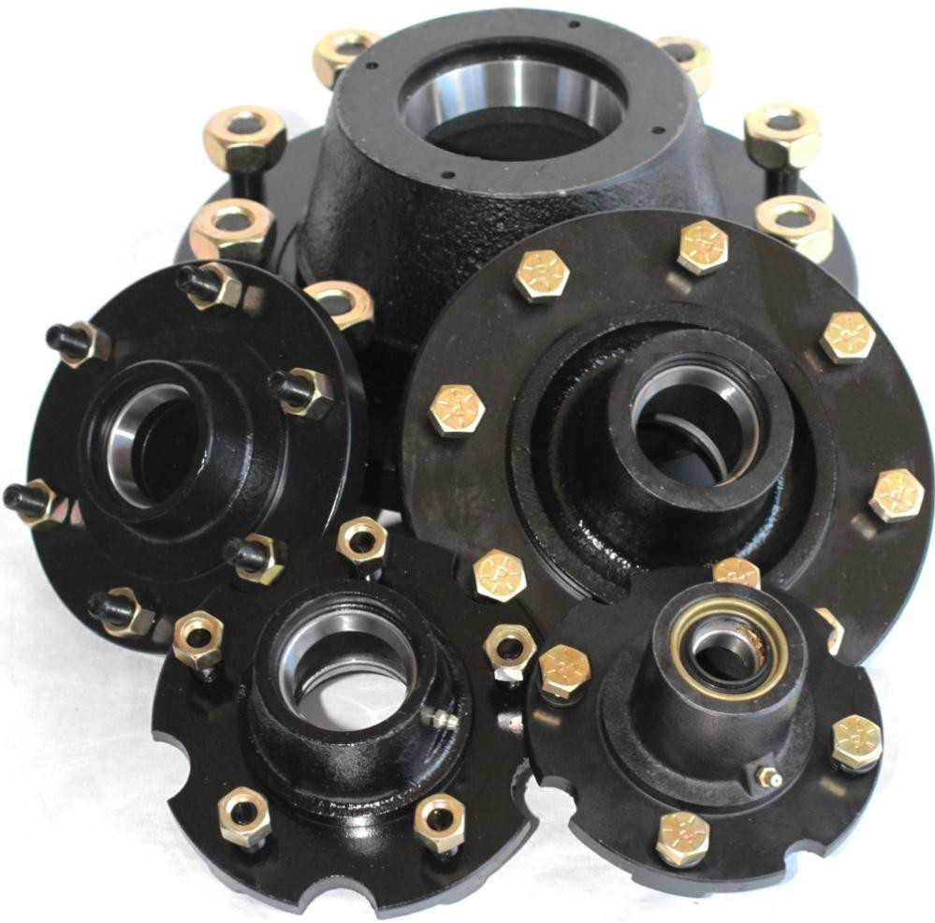
4, 5, 6, 8, 10, and 20 BOLT ASSEMBLIES

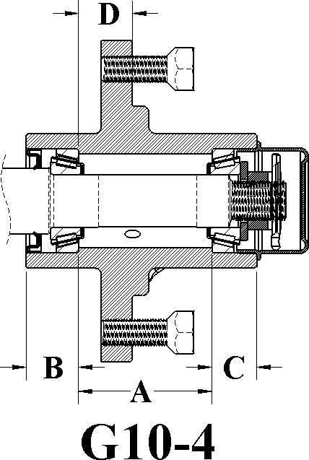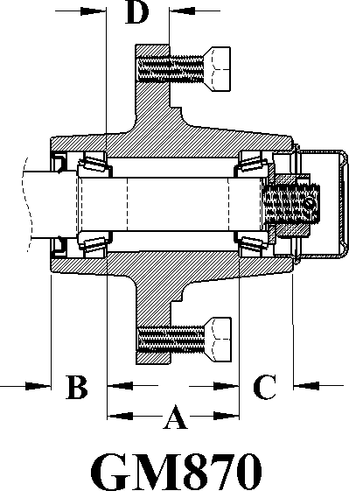

MOD | CAP LBS | HUB COMP | HUB CUPS | INNER CUP | OUTER CUP | INNER CONE | BORE DIA. | OUTER CONE | BORE DIA. | HUB CAP | BOLT | SEAL | A | B | C | D
G10-4 | 1000 | G281100 | G281101 | G910250 L44610 | G910250 L44610 | G910254 L44643 | 1.00 | G910254 L44643 | 1.00 | G909900 | G943549 | G906282 | 2.53 | 0.85 | 1.00 | 0.38
GM870 | 1250 | G280898 | G280899 | G910250 L44610 | G910250 L44610 | G910254 L44643 | 1.00 | G910254 L44643 | 1.00 | G909900 | G943549 | G906282 | 2.45 | 1.04 | 1.00 | 1.17
`
*Hub capacity based on 0.38” negative offset.*

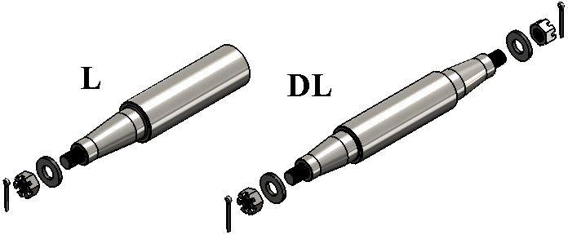

FITS MOD # | MAT’L | MAT’L DIA. | SPINDLE PACKAGE | SPINDLE ONLY | WASHER | NUT | PIN | OVERALL LENGTH | THREAD | SEAL DIA.
G10-4 | CRS | 1-1/4” | G281317 | G281280 | G910608 | G912953 | G905935 | 8.500” | ¾-16 | 1.25
GM870 | CRS | 1-1/4” | G281317 | G281280 | G910608 | G912953 | G905935 | 8.500” | ¾-16 | 1.25

For customer specific spindle needs, please refer to the Spindle Special Order page (Page 5).

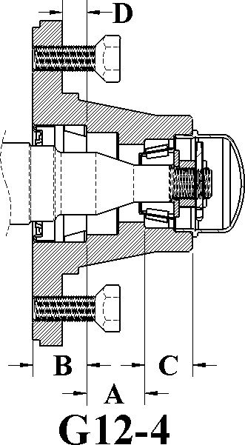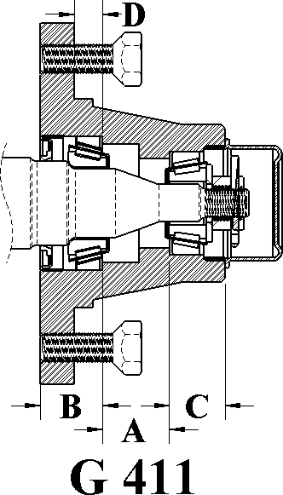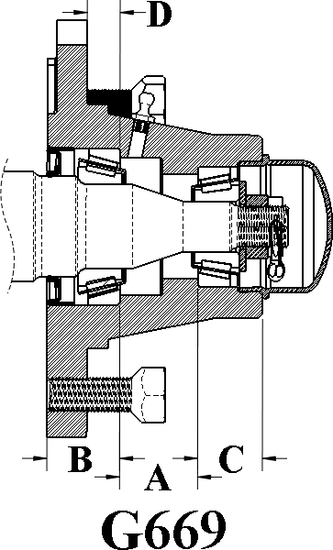

MOD | CAP  LBS | HUB  COMP | HUB  CUPS | INNER  CUP | OUTER  CUP | INNER  CONE | BORE  DIA. | OUTER  CONE | BORE  DIA. | HUB  CAP | BOLT | SEAL | A | B | C | D
G12-4 | 1250 | G281000 | G281001 | G910257 LM67010 | G910258 LM11910 | G910259 LM67048 | 1.25 | G910260 LM11949 | 0.75 | G909931 | G943549 | G906293 | 1.16 | 0.94 | 0.88 | 0.38
G411 | 1250 | G289040 | G289041 | G910257 LM67010 | G910258 LM11910 | G910259 LM67048 | 1.25 | G910260 LM11949 | 0.75 | G909907 | G943549 | G906296 | 1.16 | 0.97 | 0.88 | 0.38
G669 | 1250 | G280610 | G280611 | G910257 LM67010 | G910258 LM11910 | G910259 LM67048 | 1.25 | G910260 LM11949 | 0.75 | G909931 | G943549 | G906296 | 1.16 | 0.94 | 0.88 | 0.38

*G411 Is Similar To The G669 Contact G.E.P. For Special Ordering.*
*Hub capacity based on 0.38” negative offset.*
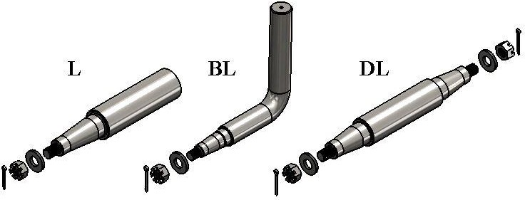

FITS MOD # | MAT’L | MAT’L DIA. | SPINDLE PACKAGE | SPINDLE ONLY | WASHER | NUT | PIN | OVERALL LENGTH | THREAD | SEAL DIA.
G12-4 | CRS | 1-5/8" | G281300 | G281200 | G913615 | G912954 | G905937 | 10.000" | 5/8-18" | 1.625
G411 | CRS | 1-5/8" | G289541 | G289540 | G913608 | G912953 | G950935 | 10.000" | 3/4-16" | 1.500
G669 | CRS | 1-5/8" | G280772 | G280771 | G913615 | G912954 | G905937 | 10.000" | 5/8-18" | 1.500

For customer specific spindle needs, please refer to the Spindle Special Order page (Page 5).

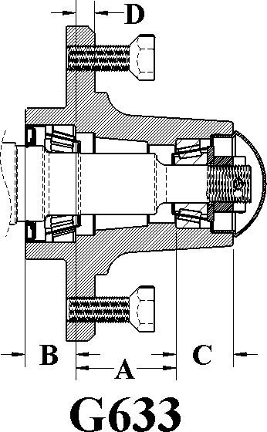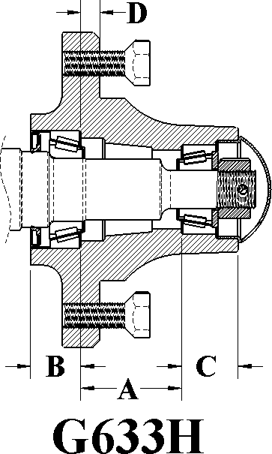

LIGHT VERSION HEAVY VERSION

MOD | CAP LBS | HUB COMP | HUB CUPS | INNER CUP | OUTER CUP | INNER CONE | BORE DIA. | OUTER CONE | BORE DIA. | HUB CAP | BOLT | SEAL | A | B | C | D
G633 | 1250 | G280448 | G280449 | G910257  LM67010 | G910258  LM11910 | G910259  LM67048 | 1.25 | G910260  LM11949 | 0.75 | G909911 | G943549 | G906296 | 2.00 | 1.00 | 1.12 | 0.38
G633H | 1500 | G280500 | G280501 | G910257 LM67010 | G910258 LM11910 | G910259 LM67048 | 1.25 | G910260 LM11949 | 0.75 | G909911 | G943549 | G906296 | 2.00 | 1.00 | 1.12 | 0.38
*Hub capacity based on 0.38” negative offset.*

FITS MOD # | MAT’L | MAT’L DIA. | SPINDLE PACKAGE | SPINDLE ONLY | WASHER | NUT | PIN | OVERALL LENGTH | THREAD | SEAL DIA.
G633 | CRS | 1-5/8" | G280741 | G280700 | G913608 | G912953 | G905935 | 9.250" | 3/4-16" | 1.500
G633H | CRS | 1-5/8" | G280741 | G280700 | G913608 | G912953 | G905935 | 10.375" | 3/4-16" | 1.500

For customer specific spindle needs, please refer to the Spindle Special Order page (Page 5).

5-Bolt, On 5.5” B.C., 4” Pilot
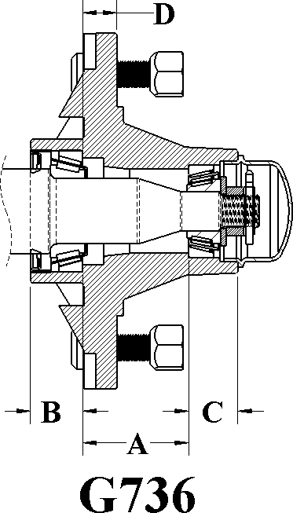
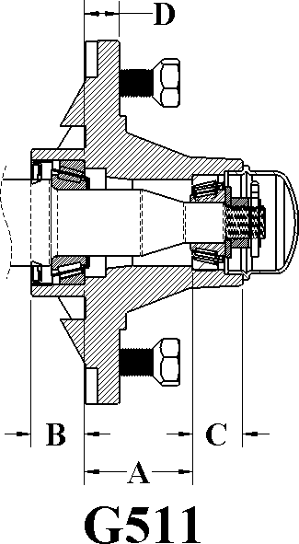
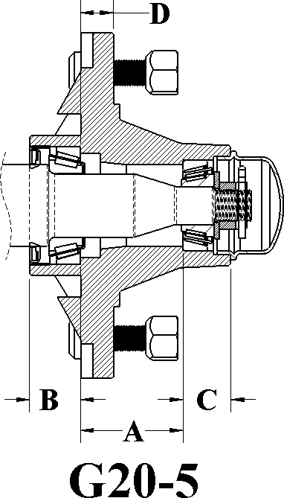

MOD | CAP LBS | HUB COMP | HUB CUPS | INNER CUP | OUTER CUP | INNER CONE | BORE DIA. | OUTER CONE | BOR  E DIA. | HUB CAP | BOLT | STUD NUT | SEAL | A | B | C | D
G736 | 2000 | G280540 | G250541 | G910257 LM67010 | G910258 LM11910 | G910259 LM67048 | 1.25 | G910260 LM11949 | 0.75 | G909931 | G943549 | G913576 G912919 | G906296 | 2.00 | 1.00 | 0.94 | 0.62
G511 | 2000 | G289050 | G289051 | G910257  LM67010 | G910258  LM11910 | G910259  LM67048 | 1.25 | G910260  LM11949 | 0.75 | G909931 | G943549 | G943549 | G906296 | 2.00 | 1.00 | 0.94 | 0.63
G20-5 | 2000 | G281050 | G281059 | G910257  LM67010 | G910258  LM11910 | G910259  LM67048 | 1.25 | G910260  LM11949 | 0.75 | G909931 | G943549 | G913576  G912919 | G906293 | 2.00 | 1.00 | 0.94 | 0.63
*Hub capacity based on 0.25” negative offset.*

FITS MOD # | MAT’L | MAT’L DIA. | SPINDLE PACKAGE | SPINDLE ONLY | WASHER | NUT | PIN | OVERALL LENGTH | THREAD | SEAL DIA.
G736 | CRS | 1-5/8" | G280741 | G280700 | G913608 | G912953 | G905935 | 10.375" | 3/4-16" | 1.500
G511 | CRS | 1-5/8" | G289551 | G289550 | G913608 | G912953 | G905935 | 10.375" | 3/4-16" | 1.500
G20-5 | CRS | 1-5/8" | G281304 | G281240 | G913615 | G912954 | G905937 | 10.000" | 5/8-18" | 1.625

For customer specific spindle needs, please refer to the Spindle Special Order page (Page 5).

5-Bolt, 5.5” Bolt Circle, 4” Pilot
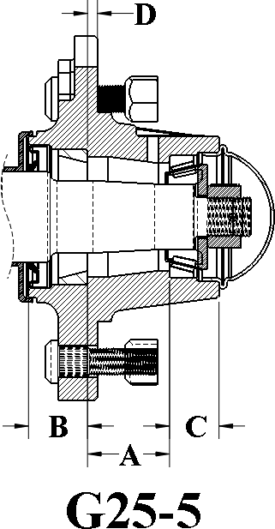
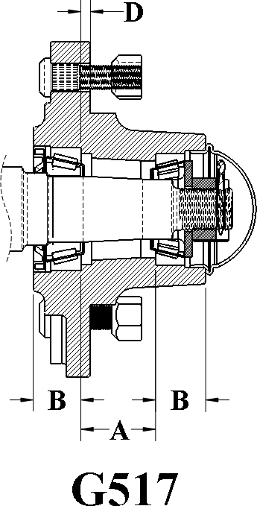
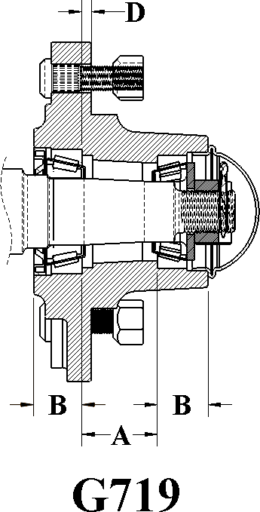

MOD | CAP LBS | HUB COMP | HUB CUPS | INNER CUP | OUTER CUP | INNER CONE | BORE DIA. | OUTER CONE | BORE DIA. | HUB CAP | STUD | NUT | SEAL | A | B | C | D
G25-5 | 2500 | G281010 | G281019 | G910261 LM48510 | G910257 LM67010 | G910262 LM48548 | 1.38 | G910259 LM67048 | 1.25 | G909905 | G913576 | G912919 | G906295 | 1.56 | 1.03 | 0.94 | 0.19
G517 | 2760 | G289066 | G289067 | G910261 LM48510 | G910257 LM67010 | G910262 LM48548 | 1.38 | G910259 LM67048 | 1.25 | G909905 | G913576 | G912919 | G906295 | 1.56 | 1.00 | 1.06 | 0.22
G719 | 2760 | G280520 | G280521 | G910261 LM48510 | G910257 LM67010 | G910262 LM48548 | 1.38 | G910259 LM67048 | 1.25 | G909905 | G913576 | G912919 | G906283 | 1.56 | 1.00 | 1.06 | 0.22
*Hub capacity based on 0.25” negative offset.*

FITS MOD # | MAT’L | MAT’L DIA. | SPINDLE PACKAGE | SPINDLE ONLY | WASHER | NUT | PIN | OVERALL LENGTH | THREAD | SEAL DIA.
G25-5 | CRS | 1-3/4" | G281301 | G281210 | G913616 | G912953 | G905935 | 12.312" | 3/4-16" | 1.75
G517 | CRS | 1-3/4" | G281301 | G281210 | G913616 | G912953 | G905935 | 12.312" | 3/4-16" | 1.75
G719 | CRS | 1-3/4" | G280742 | G280710 | G913607 | G912952 | G905936 | 11.500" | 7/8-14" | 1.50

For customer specific spindle needs, please refer to the Spindle Special Order page (Page 5).

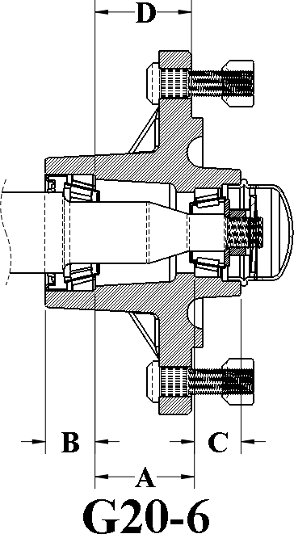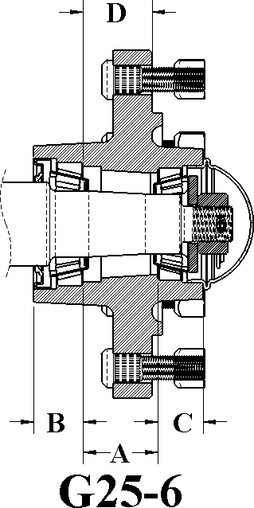

MOD | CAP LBS | HUB COMP | HUB CUPS | INNER CUP | OUTER CUP | INNER CONE | BORE DIA. | OUTER CONE | BORE DIA. | HUB CAP | STUD | NUT | SEAL | A | B | C | D
G20-6 | 2000 | G281060 | G281069 | G910257 LM67010 | G910258 LM11910 | G910259 LM67048 | 1.25 | G910260 LM11949 | 0.75 | G909931 | G913576 | G912919 | G906293 | 2.00 | 1.00 | 0.94 | 1.94
G25-6 | 2500 | G281020 | G281029 | G910261  LM48510 | G910257  LM67010 | G910262  LM48548 | 1.38 | G910259  LM67048 | 1.25 | G909905 | G913576 | G912919 | G906295 | 1.56 | 1.03 | 0.94 | 1.44

*Hub capacity based on 1.12” positive offset.*

ITS MOD # | MAT’L | MAT’L DIA. | SPINDLE PACKAGE | SPINDLE ONLY | WASHER | NUT | PIN | OVERALL LENGTH | THREAD | SEAL DIA.
G20-6 | CRS | 1-5/8" | G281304 | G281240 | G913615 | G912954 | G905937 | 10.000" | 5/8-18 | 1.625
G25-6 | CRS | 1-3/4" | G281301 | G281210 | G913616 | G912953 | G905935 | 12.312" | 3/4-16 | 1.750

For customer specific spindle needs, please refer to the Spindle Special Order page (Page 5).

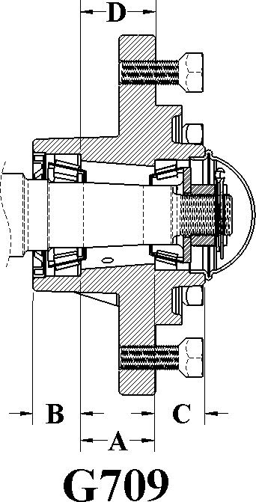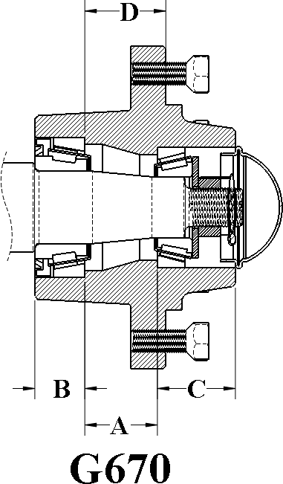

MOD | CAP LBS | HUB COMP | HUB CUPS | INNER CUP | OUTER CUP | INNER CONE | BORE DIA. | OUTER CONE | BORE DIA. | HUB CAP | BOLT | SEAL | A | B | C | D
G709 | 2760 | G280510 | G280511 | G910261 LM48510 | G910257 LM67010 | G910262 LM48548 | 1.38 | G910259 LM67048 | 1.25 | G909905 | G943549 | G906283 | 1.56 | 1.00 | 1.06 | 1.59
G670 | 3230 | G280590 | G280591 | G910288 332 | G910290 14276 | G910289 342A | 1.62 | G910291 14137A | 1.38 | G909928 | G943549 | G906487 | 1.62 | 1.13 | 1.75 | 1.81

*Hub capacity based on 1.12” positive offset.*
*G670 Hub's Seal Rides on The Bearing/Cone Flange*

FITS MOD # | MAT’L | MAT’L DIA. | SPINDLE PACKAGE | SPINDLE ONLY | WASHER | NUT | PIN | OVERALL LENGTH | THREAD | SEAL DIA.
G709 | CRS | 1-3/4" | G280742 | G280710 | G913607 | G912952 | G905936 | 11.500" | 7/8-14" | 1.500"
G670 | CRS | 2.00" | G280963 | G280964 | G913683 | G912952 | G905936 | 11.000" | 7/8-14" | 2.297"

For customer specific spindle needs, please refer to the Spindle Special Order page (Page 5).

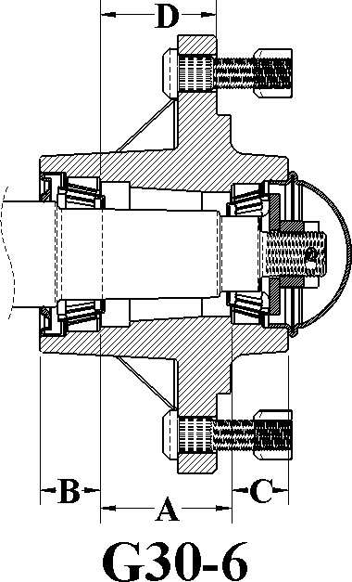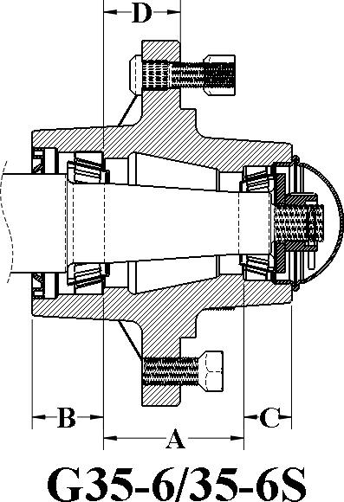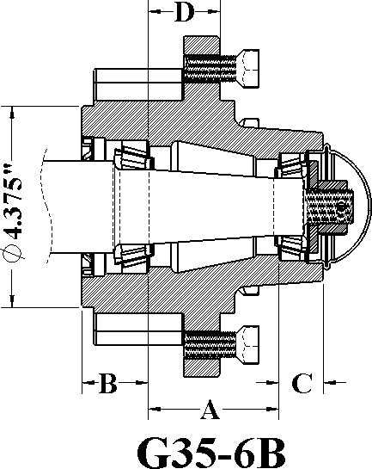

MOD | CAP LBS | HUB COMP | HUB CUPS | INNER CUP | OUTER CUP | INNER CONE | BORE DIA. | OUTER CONE | BORE DIA. | HUB CAP | BOLT STUD NUT | SEAL | A | B | C | D
30-6 | 3000 | G281030 | G281039 | G910274 LM29710 | G910257 LM67010 | G910275 LM29749 | 1.50 | G910259 LM67048 | 1.25 | G909905 | G913548 G913549 | G906295 | 2.19 | 1.00 | .94 | 1.94
35-6 | 3500 | G281040 | G281041 | G910272 LM501310 | G910257 LM67010 | G910273 LM501349 | 1.62 | G910259 LM67048 | 1.25 | G909905 | G913538 | G906294 | 2.84 | 1.44 | .97 | 1.56
35-6S | 3500 | G281056 | G281044 | G910272 LM501310 | G910257 LM67010 | G910273 LM501349 | 1.62 | G910259 LM67048 | 1.25 | G909905 | G913548 G913549 | G906294 | 2.84 | 1.44 | .97 | 1.56
35-6B | 3500 | G281560 | G281561 | G910272 LM501310 | G910257 LM67010 | G910273 LM501349 | 1.62 | G910259 LM67048 | 1.25 | G909905 | G913538 | G906294 | 2.84 | 1.44 | .97 | 1.56

*Bolt Pattern For Brake On Model G35-6 Is 6 Bolt On 5.50" (1/2-20 UNF)*
*Hub capacity based on 1.12” positive offset.*
*G35-6B Hub Is By Request Only.*

FITS MOD # | MAT’L | MAT’L DIA. | SPINDLE PACKAGE | SPINDLE ONLY | WASHER | NUT | PIN | OVERALL LENGTH | THREAD | SEAL DIA.
G30-6 | CRS | 1-3/4" | G281302 | G281220 | G913616 | G912953 | G905935 | 12.000" | 3/4-16 | 1.750"
G35-6 | CRS | 2" | G281303 | G281230 | G913616 | G912953 | G905935 | 14.000" | 3/4-16 | 2.000"

For customer specific spindle needs, please refer to the Spindle Special Order page (Page 5).

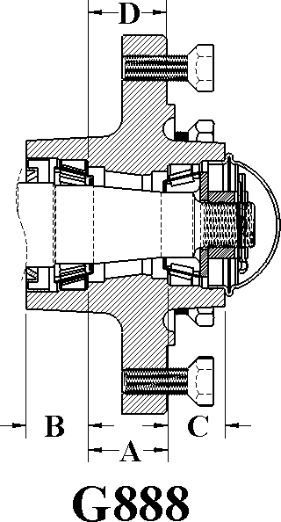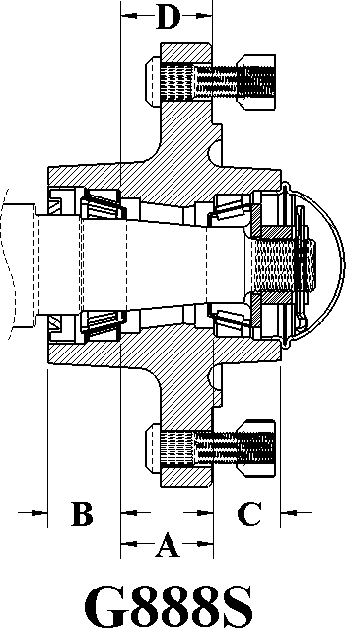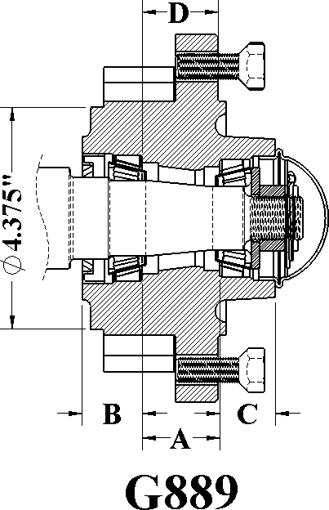

MOD | CAP LBS | HUB COMP | HUB CUPS | INNER CUP | OUTER CUP | INNER CONE | BORE DIA. | OUTER CONE | BORE DIA. | HUB CAP | BOLT | STUD NUTS | SEAL | A | B | C | D
G888 | 3560 | G280550 | G280551 | G910263  JL69310 | G910257  LM67010 | G910264  JL69349 | 1.50 | G910259  LM67048 | 1.25 | G909905 | G943549 | N/A | G906284 | 1.53 | 1.09 | 1.00 | 1.53
G888S | 3560 | G280640 | G280641 | G910263 JL69310 | G910257 LM67010 | G910264 JL69349 | 1.50 | G910259 LM67048 | 1.25 | G909905 | N/A | G913576 G912919 | G906284 | 1.53 | 1.09 | 1.00 | 1.53
G889 | 3560 | G280630 | G280631 | G910263 JL69310 | G910257 LM67010 | G910264 JL69349 | 1.50 | G910259 LM67048 | 1.25 | G909905 | G943549 | N/A | G906284 | 1.53 | 1.09 | 1.00 | 1.53

*Bolt Pattern For Brake On Model G889 Is 6 Bolt On 5.50" (1/2-20 UNF)
*Hub Capacity Based On 1.12” Positive Offset.*

FITS MOD # | MAT’L | MAT’L DIA. | SPINDLE PACKAGE | SPINDLE ONLY | WASHER | NUT | PIN | OVERALL LENGTH | THREAD | SEAL DIA.
G888 | CRS | 1-3/4" | G280743 | G280720 | G913607 | G912952 | G905936 | 12.500 | 7/8-14" | 1.625
G888S | CRS | 1-3/4" | G280743 | G280720 | G913607 | G912952 | G905936 | 12.500 | 7/8-14" | 1.625
G889 | CRS | 2" | G280722 | G280721 | G913607 | G912952 | G905936 | 14.000 | 7/8-14" | 1.625

For customer specific spindle needs, please refer to the Spindle Special Order page (Page 5).

-Bolt, 6” Bolt Circle, 4.62” Pilot
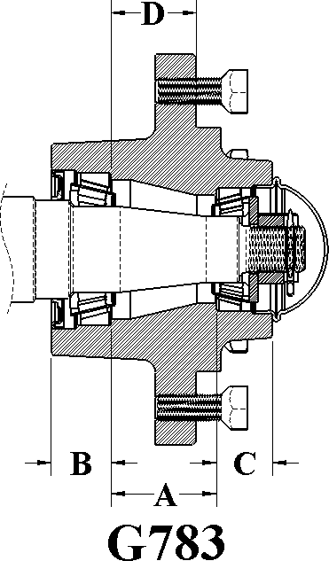
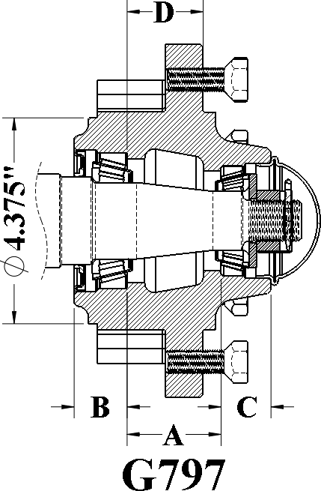

MOD | CAP LBS | HUB COMP | HUB CUPS | INNER CUP | OUTER CUP | INNER CONE | BORE DIA. | OUTER CONE | BORE DIA. | HUB CAP | BOLT | SEAL | A | B | C | D
G783 | 4570 | G289010 | G289011 | G910272 LM501310 | G910257 LM67010 | G910273 LM501349 | 1.62 | G910259 LM67048 | 1.25 | G909905 | G943549 | G906493 | 2.00 | 1.13 | 1.06 | 1.62
G797 | 4570 | G287060 | G287061 | G910272 LM501310 | G910257 LM67010 | G910273 LM501349 | 1.62 | G910259 LM67048 | 1.25 | G909905 | G943549 | G906985 | 2.00 | 1.13 | 1.06 | 1.62
*Bolt Pattern For Brake On Model G797 Is 6 On 5.50" B.C. (1/2-20 UNF)*
- Hub Capacity Based On 1.12” Positive Offset.*

FITS MOD # | MAT’L | MAT’L DIA. | SPINDLE PACKAGE | SPINDLE ONLY | WASHER | NUT | PIN | OVERALL LENGTH | THREAD | SEAL DIA.
G783 | CRS | 2.00" | G289511 | G289510 | G913607 | G912952 | G905936 | 14.000" | 7/8-14 | 1.875
G797 | CRS | 2-7/16" | G287320 | G287321 | G913607 | G912952 | G905936 | 16.000" | 7/8-14 | 2.250

For customer specific spindle needs, please refer to the Spindle Special Order page (Page 5).

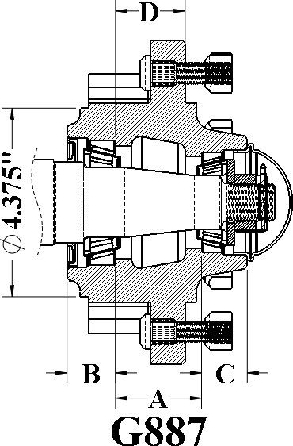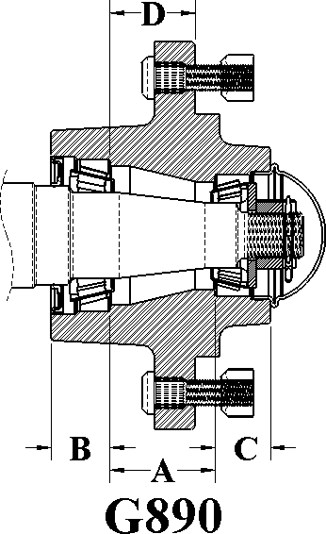

MOD | CAP LBS | HUB COMP | HUB CUPS | INNER CUP | OUTER CUP | INNER CONE | BORE DIA. | OUTER CONE | BORE DIA. | HUB CAP | STUD NUT | SEAL | A | B | C | D
G887 | 4570 | G287880 | G287881 | G910272  LM501310 | G910257  LM67010 | G910273  LM501349 | 1.62 | G910259  LM67048 | 1.25 | G909905 | G913576  G912919 | G906985 | 2.00 | 1.12 | 1.06 | 1.68
G890 | 4570 | G287890 | G287891 | G910272 LM501310 | G910257 LM67010 | G910273 LM501349 | 1.62 | G910259 LM67048 | 1.25 | G909905 | G913576 G912919 | G906493 | 2.00 | 1.31 | 1.06 | 1.62

*Bolt Pattern For Brake On Model G887 Is 6 On 5.50" B.C. (1/2-20 UNF)*
- Hub Capacity Based On 1.12” Positive Offset.*

FITS MOD # | MAT’L | MAT’L DIA. | SPINDLE PACKAGE | SPINDLE ONLY | WASHER | NUT | PIN | OVERALL LENGTH | THREAD | SEAL DIA.
G887 | CRS | 2-7/16" | G287320 | G287321 | G913607 | G912952 | G905936 | 16.000" | 7/8-14 | 2.250
G890 | CRS | 2.000" | G289511 | G289510 | G913607 | G912952 | G905936 | 14.000" | 7/8-14 | 1.875

For customer specific spindle needs, please refer to the Spindle Special Order page (Page 5).

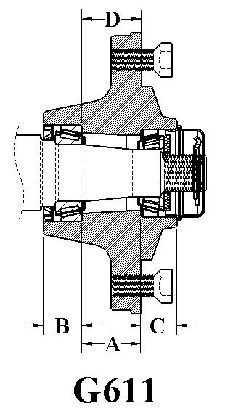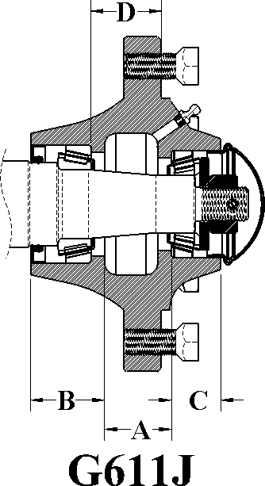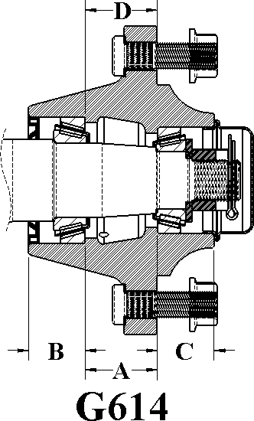

MOD | CAP LBS | HUB COMP | HUB CUPS | INNER CUP | OUTER CUP | INNER CONE | BORE DIA. | OUTER CONE | BORE DIA. | HUB CAP | BOLT | SEAL | A | B | C | D
G611 | 3600 | G289030 | G289031 | G910274 LM29710 | G910257 LM67010 | G910275 LM29749 | 1.5 | G910259 LM67048 | 1.25 | G909908 | G913538 | G906490 | 1.56 | 1.00 | 1.06 | 1.62
*G611J* | 2750 | G287036 | G287035 | G910274 LM29710 | G910257 LM67010 | G910275 LM29749 | 1.5 | G910259 LM67048 | 1.25 | G909970 | G913538 | G906492 | 1.75 | 1.31 | 1.07 | 1.53
G614 | 5000 | G289000 | G289001 | G910276 LM603011 | G910261 LM48510 | G910277 LM603049 | 1.78 | G910262 LM48548 | 1.38 | G909927 | G913538 | G906294 | 1.75 | 1.37 | 1.37 | 1.62

*Hub Capacity Based On 1.125" Positive Offset.*
*Three Piece Seal Available Upon Request.*
*The G611J fits many John Deere implements using the AN183318 Style Hub.*

FITS MOD # | MAT’L | MAT’L DIA. | SPINDLE PACKAGE | SPINDLE ONLY | WASHER | NUT | PIN | OVERALL LENGTH | THREAD | SEAL DIA.
G611 | CRS | 1.750" | G289531 | G289530 | G913622 | G912959 | G905942 | 14.000" | 1-14 UNF | 1.750
G611J | CRS | 1.875" | G289537 | G289536 | G913616 | G912953 | G905935 | 31.000" | 3/4-16 UNF | 1.804
G614 | CRS | 2.000" | G289501 | G289500 | G913622 | G912959 | G905942 | 18.000" | 1-14 UNF | 1.947

For customer specific spindle needs, please refer to the Spindle Special Order page (Page 5).

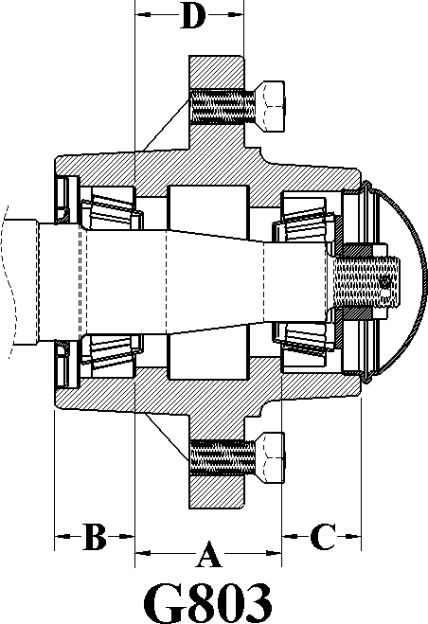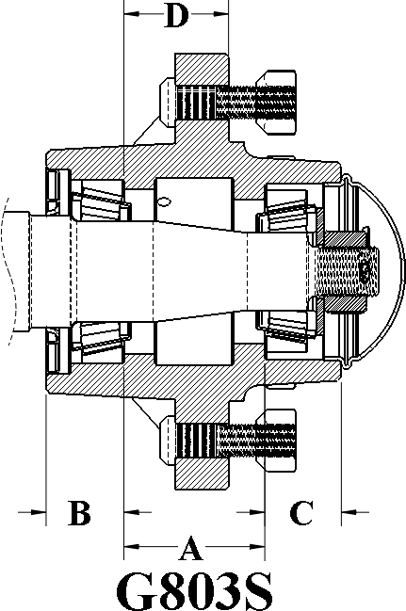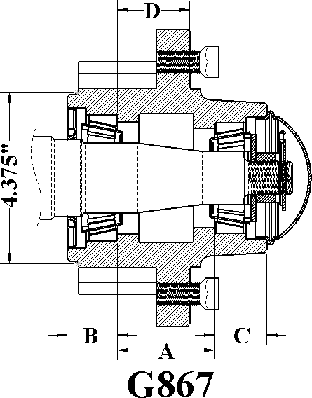

MOD | CAP LBS | HUB COMP | HUB CUPS | INNER CUP | OUTER CUP | INNER CONE | BORE DIA. | OUTER CONE | BORE DIA. | HUB CAP | BOLT STUD NUT | SEAL | A | B | C | D
G803 | 4910 | G280580 | G280581 | G910265 25520 | G910266 25821 | G910267 25590 | 1.80 | G910268 25877 | 1.38 | G909982 | G913538 | G906285 | 2.50 | 1.38 | 1.13 | 1.75
G803S | 4910 | G280570 | G280571 | G910265 25520 | G910266 25821 | G910267 25590 | 1.80 | G910268 25877 | 1.38 | G909982 | G913548 G913549 | G906285 | 2.50 | 1.38 | 1.13 | 1.75
G867 (803B) | 4910 | G286140 | G286141 | G910265 25520 | G910266 25821 | G910267 25590 | 1.80 | G910268 25877 | 1.38 | G909982 | G913538 | G906285 | 2.50 | 1.38 | 1.13 | 1.75

*Bolt Pattern For Brake On Model G867-(G803B) Is 6 On 5.50" B.C. (1/2-20 UNF)*
*Hub Capacity Based On 1.12” Negative Offset.*

FITS MOD # | MAT’L | MAT’L DIA. | SPINDLE PACKAGE | SPINDLE ONLY | WASHER | NUT | PIN | OVERALL LENGTH | THREAD | SEAL DIA.
G803 G803S G867 | CRS | 2-1/8" | G280744 | G280731 | G913683 | G912952 | G905936 | 15.437" | 7/8-14 | 2.000

For customer specific spindle needs, please refer to the Spindle Special Order page (Page 5).

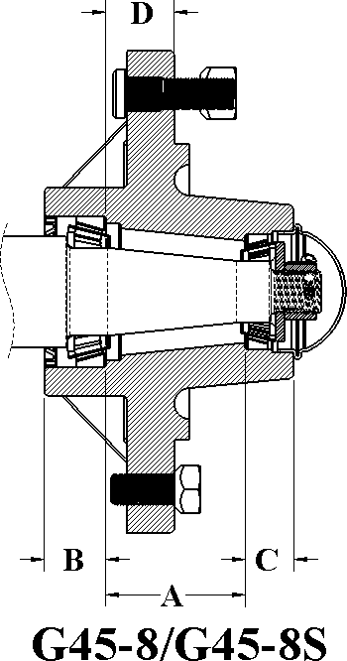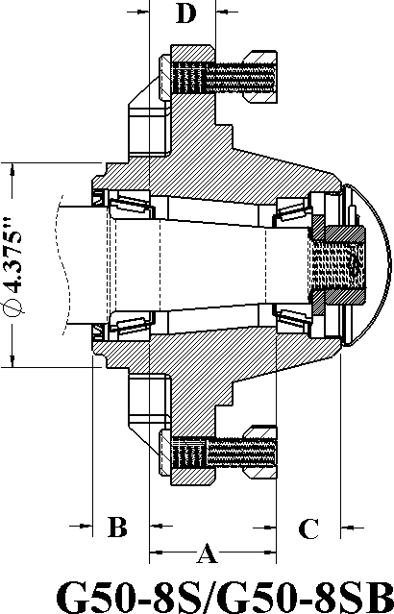

MOD | CAP LBS | HUB COMP | HUB CUPS | INNER CUP | OUTER CUP | INNER CONE | BORE DIA. | OUTER CONE | BORE DIA. | HUB CAP | BOLT STUD  NUT | SEAL | A | B | C | D
G45-8 | 4500 | G281070 | G28107 1 | G910276 LM603011 | G910257 LM67010 | G910277 LM603049 | 1.78 | G910259 LM67048 | 1.25 | G909905 | G913538 | G906297 | 2.83 | 1.26 | 0.97 | 1.38
G45-8S | 4500 | G281530 | G28158 9 | G910276 LM603011 | G910257 LM67010 | G910277 LM603049 | 1.78 | G910259 LM67048 | 1.25 | G909905 | G913556 G913557 | G906297 | 2.83 | 1.26 | 0.97 | 1.38
G50-8S | 5000 | G281373 | G28137 1 | G910304 JLM104910 | G910272 LM501310 | G910305 JLM104948 | 1.97 | G910273 LM501349 | 1.62 | G909912 | G913556 G913557 | G946492 | 2.71 | 1.21 | 1.37 | 1.42
G50-8SB | 5000 | G281374 | G28136  9 | G910304  JLM104910 | G910272  LM501310 | G910305  JLM104948 | 1.97 | G910273  LM501349 | 1.62 | G909912 | G913556  G913557 | G946492 | 2.71 | 1.21 | 1.37 | 1.42

*Bolt Pattern For Brake On Model G50-8B Is 8 On 5.50" B.C. (1/2-20 UNF)*
*G45-8 Hub Capacity Based On 1.12” Positive Offset.*
*G50-8 Hub Capacity Based On a 0.38” Positive Offset*

FITS MOD # | MAT’L | MAT’L DIA. | SPINDLE PACKAGE | SPINDLE ONLY | WASHER | NUT | PIN | OVERALL LENGTH | THREAD | SEAL DIA.
G45-8 G45-8B | CRS | 2-1/4" | G281306 | G281250 | G913616 | G912953 | G905936 | 14.000" | 3/4-16 | 2.250
G50-8 G50-8B | CRS | 2-1/2" | G286048 | G286047 | G913624 | G912959 | G905942 | 12.500" | 1-14 | 2.500

For customer specific spindle needs, please refer to the Spindle Special Order page (Page 5).

G813 Available With Studs Loose.
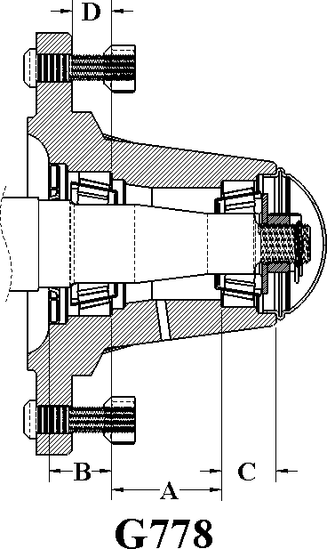
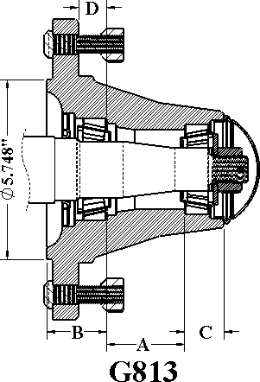

MOD | CAP LBS | HUB COMP | HUB CUPS | INNER CUP | OUTER CUP | INNER CONE | BORE DIA. | OUTER CONE | BORE DIA. | HUB CAP | BOLT STUD NUT | SEAL | A | B | C | D
G778 | 4910 | G280600 | G280601 | G910265 25520 | G910266 25821 | G910267 25590 | 1.79 | G910268 25877 | 1.38 | G909982 | G913538 | G906285 | 2.50 | 1.75 | 1.12 | 0.88
G813 | 4910 | G287180 | G287181 | G910265 25520 | G910266 25821 | G910267 25590 | 1.79 | G910268 25877 | 1.38 | G909982 | G913550 G913549 | G906285 | 2.50 | 1.75 | 1.12 | 0.88

*Bolt Pattern For Brake On Model G813 Is 8-Bolt On 8.00" Studs Thru.*
*Hub Capacity Based On 1.50” Negative Offset.*

FITS MOD # | MAT’L | MAT’L DIA. | SPINDLE PACKAGE | SPINDLE ONLY | WASHER | NUT | PIN | OVERALL LENGTH | THREAD | SEAL DIA.
G778 G813 | CRS | 2-1/8" | G280744 | G280731 | G913683 | G912952 | G905936 | 15.437" | 7/8-14 | 2.00

For customer specific spindle needs, please refer to the Spindle Special Order page (Page 5).

8-Bolt, 8” Bolt Circle, 6” Pilot
G819 Available With Studs Loose.
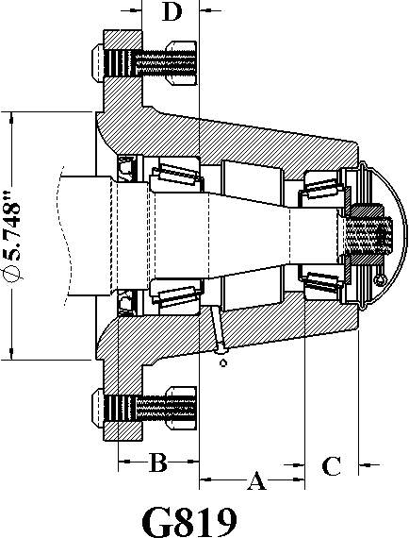
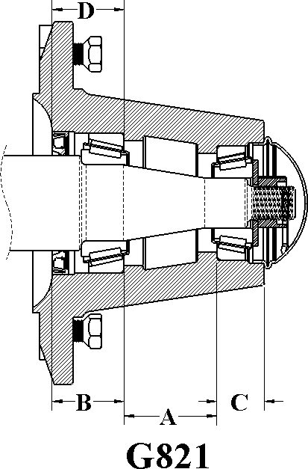

MOD | CAP LBS | HUB COMP | HUB CUPS | INNER CUP | OUTER CUP | INNER CONE | BORE DIA. | OUTER CONE | BORE DIA. | HUB CAP | BOLT STUD NUT | SEAL | A | B | C | D
G819 | 5790 | G280670 | G280671 | G910284 3720 | G910285 2720 | G910286 3780 | 2.00 | G910287 2790 | 1.31 | G909982 | G913550 G913549 | G906481 | 2.44 | 2.41 | 1.25 | 1.34
G821 | 5790 | G280680 | G280681 | G910284 3720 | G910285 2720 | G910286 3780 | 2.00 | G910287 2790 | 1.31 | G909982 | G913538 | G906481 | 2.44 | 2.41 | 1.25 | 1.34

*Bolt Pattern For Brake On Model G819 Is 8-Bolt On 8.00" Studs Thru.*
*Hub Capacity Based On 1.50” Negative Offset.*
*Longer Stud Available G913551 2-1/2" Long*
*Longer Lug Bolt Available G913955 1-1/2" Long*

FITS  MOD # | MAT’L | MAT’L  DIA. | SPINDLE  PACKAGE | SPINDLE  ONLY | WASHER | NUT | PIN | OVERALL  LENGTH | THREAD | SEAL  DIA.
G819 | CRS | 2-3/4" | G280985 | G280986 | G913683 | G912952 | G905936 | 14.380" | 7/8-14 | 2.500
G821 | CRS | 2-1/2" | G280980 | G280981 | G913683 | G912952 | G905936 | 15.437" | 7/8-14 | 2.500

For customer specific spindle needs, please refer to the Spindle Special Order page (Page 5).

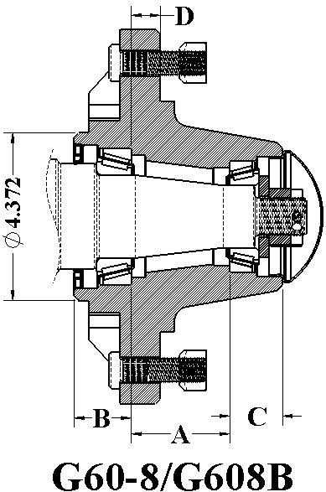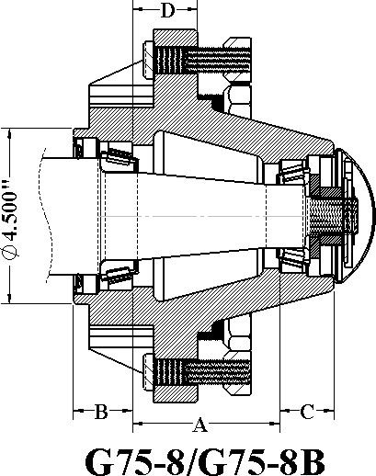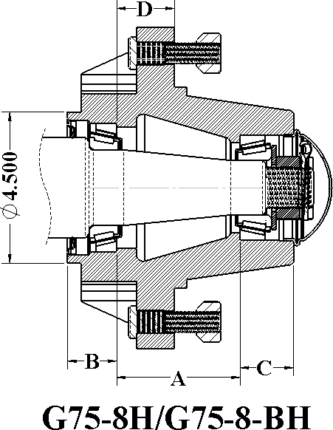

MOD | CAP  LBS | HUB  COMP | HUB  CUPS | INNER  CUP | OUTER  CUP | INNER  CONE | BORE  DIA. | OUTER  CONE | BORE  DIA. | HUB  CAP | STUD  NUT | SEAL | A | B | C | D
G60-8 | 6000 | G281080 | G281089 | G910292  JLM506810 | G910272  LM501310 | G910293  JLM506849 | 2.16 | G910273  LM501349 | 1.63 | G909912 | G913556  G913557 | G906486 | 2.56 | 1.50 | 1.37 | 0.75
G60-8B | 6000 | G281090 | G281099 | G910292  JLM506810 | G910272  LM501310 | G910293  JLM506849 | 2.16 | G910273  LM501349 | 1.63 | G909912 | G913556  G913557 | G906496 | 2.56 | 1.50 | 1.37 | 0.75
G75-8 | 7500 | G281180 | G281189 | G910358 382A | G910272 LM501310 | G910359 387AS | 2.25 | G910273 LM501349 | 1.63 | G909912 | G943541 G913557 | G946486 | 3.77 | 1.52 | 1.39 | 1.66
G75-8B | 7500 | G281520 | G281529 | G910358 382A | G910272 LM501310 | G910359 387AS | 2.25 | G910273 LM501349 | 1.63 | G909912 | G943541 G913557 | G946486 | 3.77 | 1.52 | 1.39 | 1.66
G75-8H | 8000 | G281180H | G281189H | G910358 382A | G910278 26822 | G910359 387AS | 2.25 | G910279 26882 | 1.63 | G909982 | G953021 G913571 | G946484 | 3.56 | 1.57 | 1.60 | 1.67
G75-8BH | 8000 | G281250H | G281529H | G910358  382A | G910278  26822 | G910359  387AS | 2.25 | G910279  26882 | 1.63 | G909982 | G953021  G913571 | G946484 | 3.56 | 1.57 | 1.60 | 1.67
*Brake Bolt Pattern For Hubs Above Are 8 On 5.5" B.C. (1/2-20UNF)*
*Hub Capacity Based On 0.38” Positive Offset.*

FITS MOD # | MAT’L | MAT’L DIA. | SPINDLE PACKAGE | SPINDLE ONLY | WASHER | NUT | PIN | OVERALL LENGTH | THREAD | SEAL DIA.
G60-8 | CRS | 2-3/4" | G281315 | G281260 | G913624 | G912959 | G905941 | 14.000" | 1-14 | 2.750
G75-8 | CRS | 3" | G281910 | G281911 | G913624 | G912959 | G905941 | 16.000" | 1-14 | 3.000
G75-HD | CRS | 3" | G281912 | G281813 | G913637 | G912962 | G905941 | 16.000" | 1-1/4-12 | 3.000

For customer specific spindle needs, please refer to the Spindle Special Order page (Page 5).

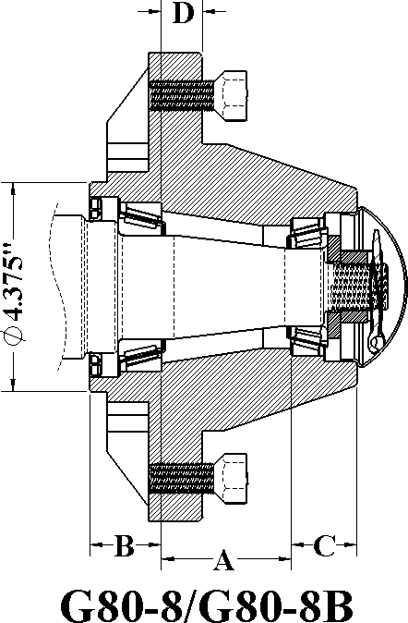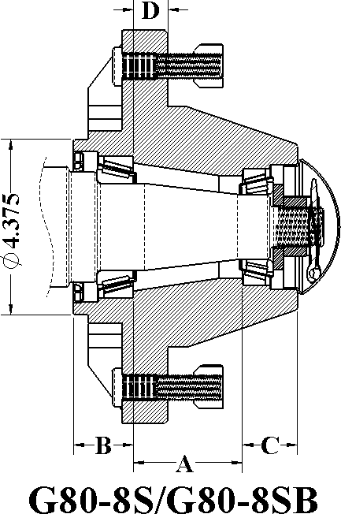

MOD | CAP LBS | HUB COMP | HUB CUPS | INNER CUP | OUTER CUP | INNER CONE | BORE DIA. | OUTER CONE | BORE DIA. | HUB CAP | BOLT STUD  NUT | SEAL | A | B | C | D
G80-8 | 8000 | G281110 | G281111 | G910292 JLM506810 | G910272 LM501310 | G910923 JLM506849 | 2.16 | G910273 LM501349 | 1.63 | G909912 | G953027 | G906486 | 2.72 | 1.50 | 1.37 | 0.83
G80-8B | 8000 | G281120 | G281121 | G910292 JLM506810 | G910272 LM501310 | G910923 JLM506849 | 2.16 | G910273 LM501349 | 1.63 | G909912 | G953027 | G906486 | 2.72 | 1.50 | 1.37 | 0.83
G80-8S | 8000 | G281510 | G281509 | G910292 JLM506810 | G910272 LM501310 | G910923 JLM506849 | 2.16 | G910273 LM501349 | 1.63 | G909930 | G913527 G913557 | G906486 | 2.72 | 1.50 | 1.37 | 0.83
G80-8SB | 8000 | G281512 | G281511 | G910292  JLM506810 | G910272  LM501310 | G910923  JLM506849 | 2.16 | G910273  LM501349 | 1.63 | G909930 | G913527  G913557 | G906486 | 2.72 | 1.50 | 1.37 | 0.83

*Brake Bolt Pattern For Hubs Above Are 8 On 5.50" B.C. (1/2-20UNF)*
*Hub Capacity Based On 0.38” Negative Offset.*

FITS MOD # | MAT’L | MAT’L DIA. | SPINDLE PACKAGE | SPINDLE ONLY | WASHER | NUT | PIN | OVERALL LENGTH | THREAD | SEAL DIA.
G80-8 | CRS | 3 | G281316 | G281270 | G913624 | G912959 | G905941 | 16.00" | 1-12 UNF | 3.000
G80-8B | CRS | 3 | G281316 | G281270 | G913624 | G912959 | G905941 | 16.00" | 1-12 UNF | 3.000
G80-8S | CRS | 3 | G281316 | G281270 | G913637 | G912962 | G905942 | 18.00" | 1-12 UNF | 3.000
G80-8S-B | CRS | 3 | G281316 | G281270 | G913624 | G912962 | G905942 | 18.00" | 1-12 UNF | 3.000

For customer specific spindle needs, please refer to the Spindle Special Order page (Page 5).

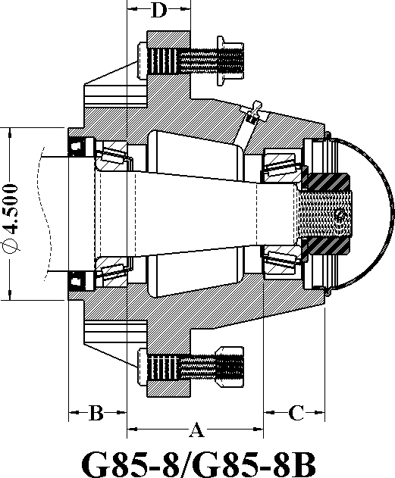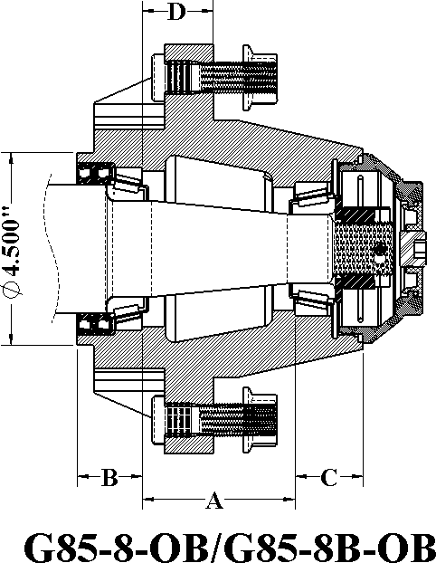

MOD | CAP LBS | HUB COMP | HUB CUPS | INNER CUP | OUTER CUP | INNER CONE | BORE DIA. | OUTER CONE | BORE DIA. | HUB CAP | STUDS LUG BOLT | SEAL | A | B | C | D
G85-8 | 8500 | G281810 | G281811 | G910358 382A | G910278 26822 | G910359 387AS | 2.25 | G910279 26882 | 1.63 | G909930 | G953021 G913571 | G906486 | 2.72 | 1.50 | 1.37 | 0.83
G85-8B | 8500 | G281820 | G281821 | G910358 382A | G910278 26822 | G910359 387AS | 2.25 | G910279 26882 | 1.63 | G909930 | G943541 G912936 | G906486 | 2.72 | 1.50 | 1.37 | 0.83
G85-8 OB | 8500 | G281830 | G281831 | G910358 382A | G910278 26822 | G910359 387AS | 2.25 | G910279 26882 | 1.63 | G909930 OB | G943541 G912936 | G906486 | 2.72 | 1.50 | 1.37 | 0.83
G85-8B- OB | 8500 | G281840 | G281841 | G910358 382A | G910278 26822 | G910359 387AS | 2.25 | G910279 26882 | 1.63 | G909930 OB | G943541 G912936 | G906486 | 2.72 | 1.50 | 1.37 | 0.83

*Brake Bolt Pattern For Hubs Above Are 8 On 5.50"B.C. (1/2-20 UNF).*
*Hub Capacity Based On 0.38” Positive Offset*
*Studs Available In Different Sizes And Lug Nuts Are Available In Flange And Hex*

FITS MOD # | MAT’L | MAT’L DIA. | SPINDLE PACKAGE | SPINDLE ONLY | WASHER | NUT | PIN | OVERALL LENGTH | THREAD | SEAL DIA.
G85-8 G85-8-OB | CRS | 3.00 | G281912 | G281913 | G913637 | G912962 | G905941 | 18.000" | 1-1/4-12 UNF | 3.000

For customer specific spindle needs, please refer to the Spindle Special Order page (Page 5).

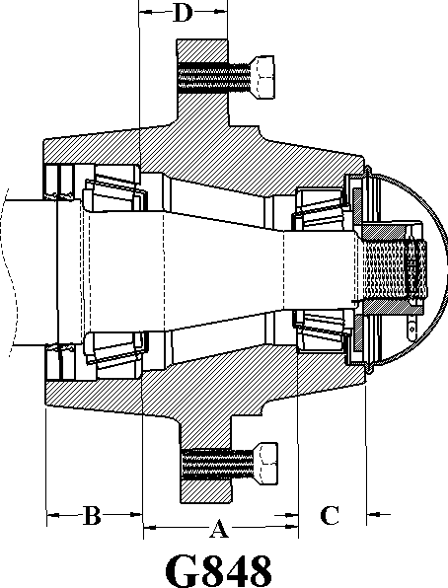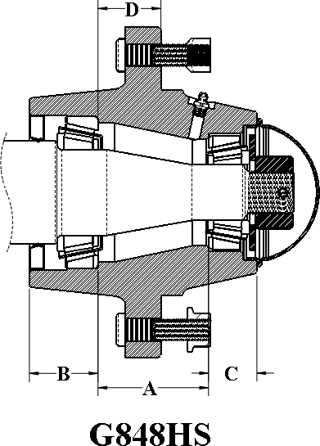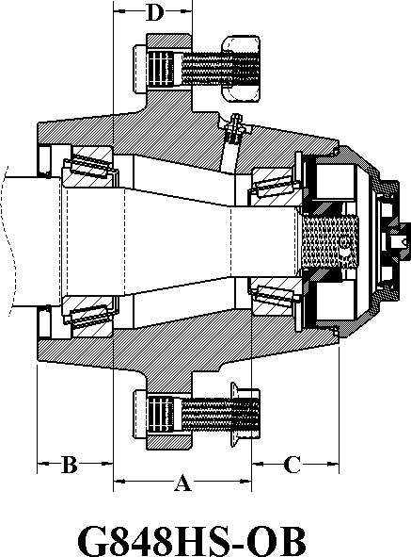

MOD | CAP  LBS | HUB  COMP | HUB  CUPS | INNER  CUP | OUTER  CUP | INNER  CONE | BORE  DIA. | OUTER  CONE | BORE  DIA. | HUB  CAP | STUD  NUT | SEAL | A | B | C | D
G848 | 8000 | G287840 | G287841 | G910331  39520 | G910352  3525 | G910354  39581 | 2.25 | G910355  3585 | 1.63 | G909930 | G913555 | G906548 | 3.22 | 1.28 | 1.41 | 1.84
G848HS | 10000 | G289842 | G289843 | G910331  39520 | G910352  3525 | G910333  39585 | 2.50 | G910355  3585 | 1.63 | G909930 | G943541  G913557 | G906497 | 3.22 | 1.28 | 1.75 | 1.84
G848H-  OB | 10000 | G289846 | G289847 | G910331  39520 | G910352  3525 | G910333  39585 | 2.50 | G910355  3585 | 1.63 | G909930-  OB | G943541  G913936 | G906497 | 3.22 | 1.28 | 1.75 | 1.84

*G848 Hub Capacity Based On 1.50” Positive Offset.*
*G848-HS And The G848HS-OB Hubs Are Made From Ductile Material*
*5/8" Studs Standard* And 3/4" Studs Available*

FITS MOD # | MAT’L | MAT’L  DIA. | SPINDLE  PACKAGE | SPINDLE  ONLY | WASHER | NUT | PIN | OVERALL  LENGTH | THREAD | SEAL DIA.
G848 | CRS | 3.625" | G287301 | G287300 | G913637 | G912962 | G905941 | 15.590" | 1-1/4-12 | 3.500"
G848-OB | CRS | 3.000" | G281918 | G281917 | G913637 | G912962 | G905941 | 16.000" | 1-1/4-12 | 3.000"
G848HS-OB | CRS | 3.000" | G281918 | G281917 | G913637 | G912962 | G905941 | 16.000" | 1-1/4-12 | 3.000"

For customer specific spindle needs, please refer to the Spindle Special Order page (Page 5).

8-Bolt, 8.000” B.C. 6” Pilot / 8-Bolt, 10.827" B.C. 8.69" Pilot
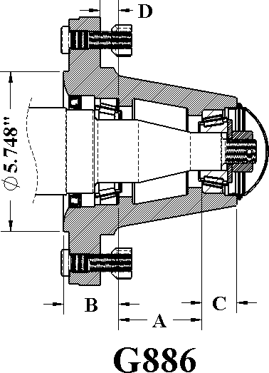
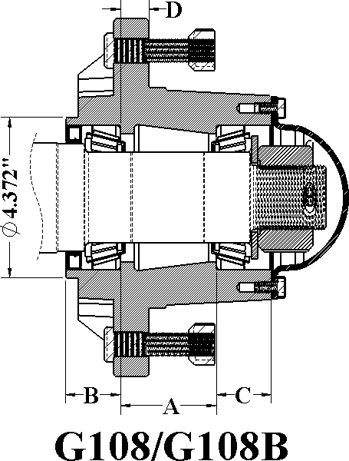
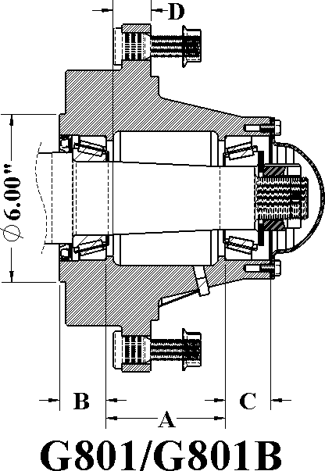

MOD | CAP  LBS | HUB  COMP | HUB  CUPS | INNER  CUP | OUTER  CUP | INNER  CONE | BORE  DIA. | OUTER  CONE | BORE  DIA. | HUB  CAP | STUD  NUT | SEAL | A | B | C | D
G886 | 8000 | G287130 | G287131 | G910358  382A | G910285  2720 | G910359  387AS | 2.25 | G910367  2793 | 1.37 | G909982 | G913556  G913557 | G946484 | 3.00 | 1.94 | 1.25 | 0.75
G108 | 10000 | G287109 | G287108 | G910327 28921 | G910327 28921 | G910326 28995 | 2.47 | G910326 28995 | 2.47 | G909980 | G943541 G913557 | G906998 | 2.61 | 1.50 | 1.50 | 0.77
G108B | 10000 | G281113 | G281112 | G910327 28921 | G910327 28921 | G910326 28995 | 2.47 | G910326 28995 | 2.47 | G909980 | G943541 G913557 | G906998 | 2.61 | 1.50 | 1.50 | 0.77
G801 | 10000 | G281584 | G281583 | G910369  3920 | G910369  3920 | G910370  3984 | 2.63 | G951021  3979 | 2.25 | G909983 | G953021  G913571 | G906474 | 4.15 | 1.66 | 1.625 | 1.60
G801B | 10000 | G281582 | G281581 | G910369  3920 | G910369  3920 | G910370  3984 | 2.63 | G951021  3979 | 2.25 | G909983 | G953021  G913571 | G906474 | 4.15 | 1.66 | 1.625 | 1.60
*G886 Hub Capacity Based On 1.50" Negative Offset*
*G108S And The G801 Hub Capacity is Based On 0” Offset*
*Bolt Pattern For Hub G886 Is 8-Bolt On 8.00" (Studs Thru)*
*Bolt Pattern For Hub G108SB And G801 Is 6-Bolt On 8.25" (1/2-20UNF)*

FITS MOD  # | MAT’L | MAT’L  DIA. | SPINDLE  PACKAGE | SPINDLE  ONLY | WASHER | NUT | PIN | OVERALL  LENGTH | THREAD | SEAL DIA.
G886 | CRS | 3.125" | G287339 | G287338 | G913683 | G912952 | G905936 | 16.000" | 7/8-14 | 3.000"
G108S | CRS | 3.000" | G281920 | G281919 | G913639 | G912932 | G905925 | 20.000" | 1-3/4-12 | 2.940"
G801 | CRS | 3.250" | G281351 | G281350 | G913639 | G953018 | G905925 | 18.000" | 1-1/2-12 | 3.250"

For customer specific spindle needs, please refer to the Spindle Special Order page (Page 5).

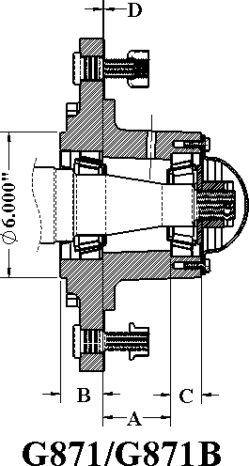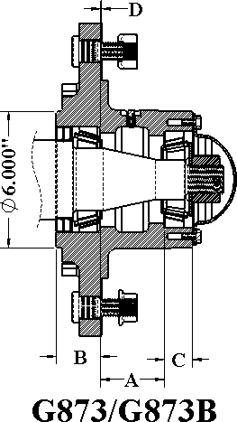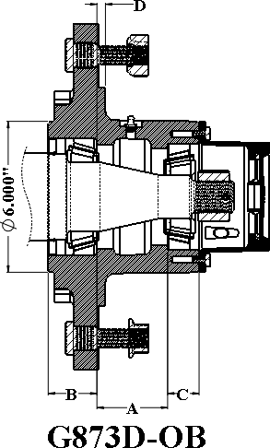

MOD | CAP LBS | HUB COMP | HUB CUPS | INNER CUP | OUTER CUP | INNER CONE | BORE DIA. | OUTER CONE | BORE DIA. | HUB CAP | STUD NUT | SEAL | A | B | C | D
G871 | 12000 | G289130 | G289141 | G910331 39520 | G910332 453A | G910333 39585 | 2.50 | G910334 460 | 1.75 | G909983 | G953033 G912935 | G906497 | 2.81 | 1.75 | 1.25 | 0.06
G871B | 12000 | G289157 | G289146 | G910331  39520 | G910332  453A | G910333  39585 | 2.50 | G910334  460 | 1.75 | G909983 | G953033  G913571 | G906497 | 2.81 | 1.75 | 1.25 | 0.06
G873 | 15000 | G289127 | G289121 | G910397  33462 | G910332  453A | G910398  33275 | 2.75 | G910334  460 | 1.75 | G909983 | G953033  G912935 | G946275 | 2.81 | 1.75 | 1.25 | 0.06
G873B | 15000 | G289135 | G289125 | G910397  33462 | G910332  453A | G910398  33275 | 2.75 | G910334  460 | 1.75 | G909983 | G953033  G913571 | G946275 | 2.81 | 1.75 | 1.25 | 0.06
G873D- OB | 16000 | G289872 | G289873 | G910397  33462 | G910332  453A | G910398  33275 | 2.75 | G910334  460 | 1.75 | G909983-OB | G953036  G912935 | G946275 | 2.81 | 1.75 | 1.25 | 0.06
G873DB- OB | 16000 | G289874 | G289875 | G910397  33462 | G910332  453A | G910398  33275 | 2.75 | G910334  460 | 1.75 | G909983_OB | G953036  G913571 | G946275 | 2.81 | 1.75 | 1.25 | 0.06

*Brake Pattern For The Above Hubs Is 6 On 8.25" B.C. (1/2-20 UNF) *
*Hub Capacity Based on 0.0” offset.*
* Hubs Are Available In Ductile Material.*
*Available with Bud, Flange, or Swivel-Flange Nuts.*

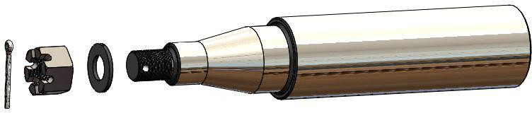

FITS MOD # | MAT’L | MAT’L DIA. | SPINDLE PACKAGE | SPINDLE ONLY | WASHER | NUT | PIN | OVERALL LENGTH | THREAD | SEAL DIA.
G871 G871B | CRS | 3-1/8" | G281309 | G281297 | G913632 | G912969 | G905941 | 17.375" | 1-1/4-12 | 3.000
G873 G873B | CRS | 3.375" | G286799 | G286802 | G913632 | G912969 | G905941 | 17.375" | 1-1/4-12 | 3.375
G873D-OB | CRS | 3.500" | G286800 | G286803 | G913632 | G912969 | G905941 | 17.375" | 1-1/4-12 | 3.375

For customer specific spindle needs, please refer to the Spindle Special Order page (Page 5).

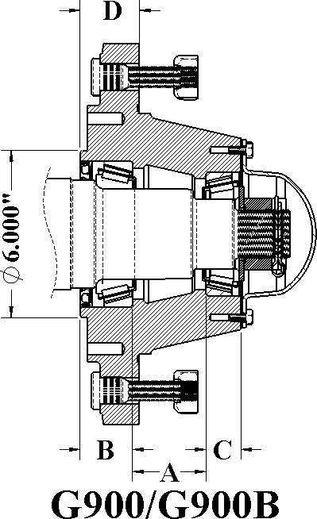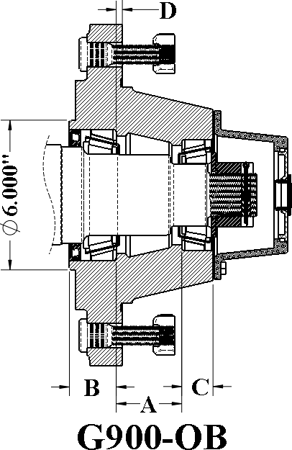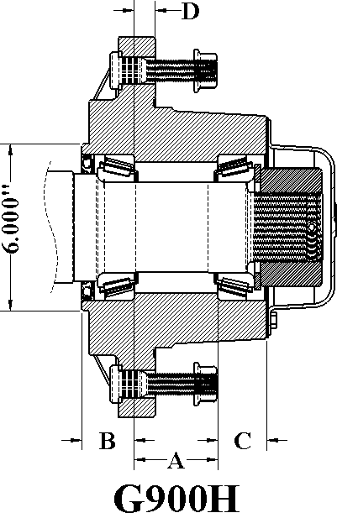

MOD | CAP LBS | HUB COMP | HUB CUPS | INNER CUP | OUTER CUP | INNER CONE | BORE DIA. | OUTER CONE | BORE DIA. | HUB CAP | STUD NUT | SEAL | A | B | C | D
G900 | 18000 | G289704 | G289703 | G910339 47620 | G910331 39520 | G910338 47687 | 3.25 | G910333 39585 | 2.50 | G909920 | G953035 G912935 | G946500 | 2.63 | 1.88 | 1.25 | 0.25
G900B | 18000 | G289706 | G289708 | G910339 47620 | G910331 39520 | G910338 47687 | 3.25 | G910333 39585 | 2.50 | G909920 | G953035 G912935 | G946500 | 2.63 | 1.88 | 1.25 | 0.25
G900-OB | 18000 | G289701 | G289702 | G910339 47620 | G910331 39520 | G910338 47687 | 3.25 | G910333 39585 | 2.50 | G909920- OB | G953035 G912935 | G946500 | 2.63 | 1.88 | 1.25 | 0.25
G900B-OB | 18000 | G289712 | G289711 | G910339 47620 | G910331 39520 | G910338 47687 | 3.25 | G910333 39585 | 2.50 | G909920- OB | G953035 G912935 | G946500 | 2.63 | 1.88 | 1.25 | 0.25
G900HD | 20000 | G289709 | G289710 | G910339 47620 | G910339 47620 | G910338 47687 | 3.25 | G910338 47687 | 3.25 | G909922 | G953035 G913571 | G946500 | 3.00 | 1.88 | 1.25 | 0.75

*Brake Pattern For The Above Hubs Is 6 On 8.25" B.C. (1/2-20 UNF)*
*Hub Capacity Based On 0.0” Offset.*
*Available With 3/4-16 or 22mm Studs/Bud, Flange, Or Swivel Flange Nuts.*
*Hubs Are Made From Ductile Material*

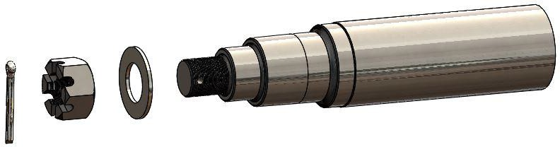

FITS MOD # | MAT’L | MAT’L DIA. | SPINDLE PACKAGE | SPINDLE ONLY | WASHER | NUT | PIN | OVERALL LENGTH | THREAD | SEAL DIA.
G900 | CRS | 4.00” | G286814 | G286815 | G913639 | G912932 | G905925 | 18.000" | 1-3/4-12 | 3.875
G900HD | CRS | 4.00” | G286921 | G286920 | G913640 | G912978 | G905959 | 19.063" | 2-1/2-12 | 3.875

For customer specific spindle needs, please refer to the Spindle Special Order page (Page 5).

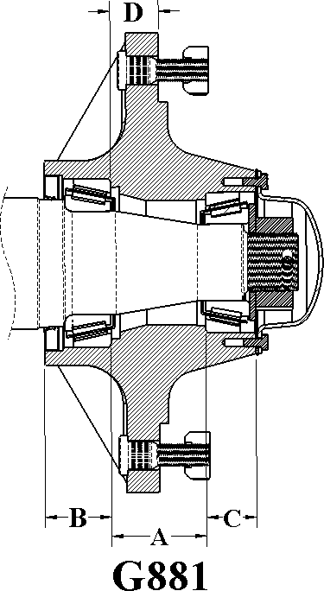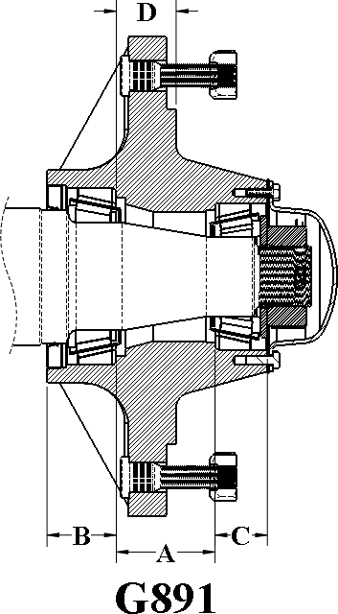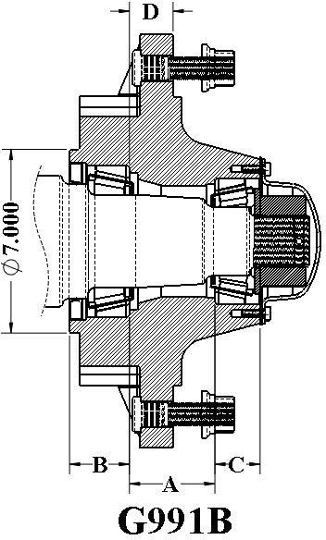

MOD | CAP LBS | HUB COMP | HUB CUPS | INNER CUP | OUTER CUP | INNER CONE | BORE DIA. | OUTER CONE | BORE DIA. | HUB CAP | STUD NUT | SEAL | A | B | C | D
G881 | 20000 | G281170 | G281171 | G910344 HM218210 | G910384 HM212011 | G910346 HM218248 | 3.54 | G910347 HM212049 | 2.62 | G909921 | G953033 G913571 | G906979 | 3.25 | 2.28 | 1.72 | 1.66
G891 | 22500 | G289171 | G289172 | G910344  HM218210 | G910384  HM212011 | G910346  HM218248 | 3.54 | G910347  HM212049 | 2.62 | G909921 | G953035  G913571 | G906979 | 3.25 | 2.28 | 1.72 | 1.66
G991B | 25000 | G281173 | G281174 | G910344 HM218210 | G910384 HM212011 | G910346 HM218248 | 3.54 | G910347 HM212049 | 2.62 | G909921 | G913472 G913480 | G906979 | 3.25 | 2.28 | 1.72 | 1.66

* Bolt Pattern For The G991B Model Is 10 On 11.00" B.C. (1/2-20UNF)*
*Hub Capacity Based On 1.50” Positive Offset.*
*Available With 3/4-16 or 22mm Studs/Bud, Flange, Or Swivel Flange Nuts.*
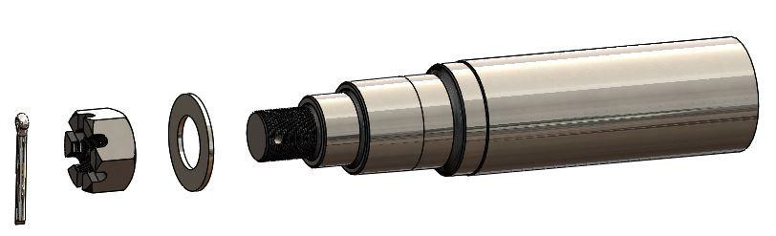*G891 And The G991B Are Made From Ductile Material.*
\

FITS  MOD # | MAT’L | MAT’L  DIA. | SPINDLE  PACKAGE | SPINDLE ONLY | WASHER | NUT | PIN | OVERALL  LENGTH | THREAD | SEAL  DIA.
G881 | CRS | 4.50" | G281914 | G281915 | G913635 | G912973 | G905957 | 18.500" | 2-12 UNF | 4.375
G891 | CR-1144 | 4.50" | G281921 | G281922 | G913635 | G912973 | G905957 | 21.250" | 2-12 UNF | 4.375
G991 | 4140 | 5.00" | G281925 | G281926 | G913535 | G912975 | G905957 | 23.925" | 2-12 UNF | 4.375

For customer specific spindle needs, please refer to the Spindle Special Order page (Page 5).

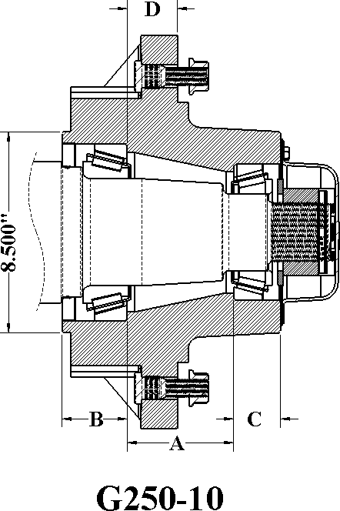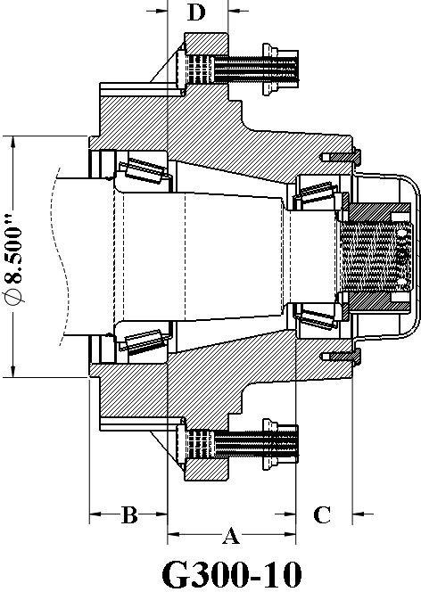

MOD | CAP LBS | HUB COMP | HUB CUPS | INNER CUP | OUTER CUP | INNER CONE | BORE DIA. | OUTER CONE | BORE DIA. | HUB CAP | STUD NUT | SEAL | A | B | C | D
G250-10 | 30000 | G281178 | G281177 | G910335 71750 | G910385 653 | G910350 71455 | 4.53 | G910351 663 | 3.25 | G909922 | G953035 G913571 | G946499 | 4.51 | 2.75 | 1.99 | 2.13
G300-10 | 35000 | G289184 | G289183 | G910335 71750 | G910385 653 | G910350 71455 | 4.53 | G910351 663 | 3.25 | G909922 | G913475 G913480 | G946499 | 4.51 | 2.75 | 1.99 | 2.13

*Hub Capacity Based On 1.50" Positive Offset*
*Bolt Pattern For Brake Version Hub Is 10 on 11.00" B.C. (1/2-20 UNF)*
*Available With 3/4-16 or 22mm Studs/Bud, Flange, Or Swivel Flange Nuts.*
*G300-10 Hub Is Made From Ductile Material*

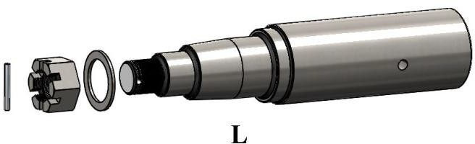

FITS MOD # | MAT’L | MAT’L  DIA. | SPINDLE  PACKAGE | SPINDLE  ONLY | WASHER | NUT | PIN | OVERALL  LENGTH | THREAD | SEAL  DIA.
G250-10 G300-10 | CRS | 6.00" | G281931 | G281932 | G913640 | G912978 | G905959 | 25.345" | 2-1/2-12  UNF | 5.500

For customer specific spindle needs, please refer to the Spindle Special Order page (Page 5).

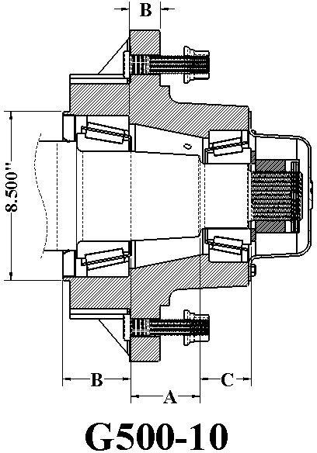

MOD | CAP LBS | HUB COMP | HUB CUPS | INNER CUP | OUTER CUP | INNER CONE | BORE DIA. | OUTER CONE | BORE DIA. | HUB CAP | STUD NUT | SEAL | A | B | C | D
G500-10 | 50000 | G289190 | G289191 | G910400 930 | G910405 832 | G910401 938 | 4.50 | G910406 842 | 3.25 | G909924 | G913475 G913480 | G946550 | 4.63 | 3.38 | 2.50 | 1.63

*Hub Capacity Based On 1.50" Offset.*
*Bolt Pattern For Brake Version Hub Is 10 On 11.00" B.C. (1/2-20 UNF).*
*G500-10 Hub Is Made From Ductile Material*

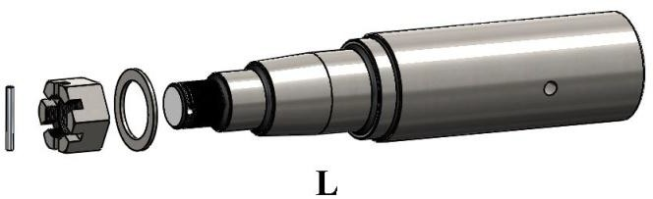

FITS MOD  # | MAT’L | MAT’L  DIA. | SPINDLE  PACKAGE | SPINDLE  ONLY | WASHER | NUT | PIN | OVERALL  LENGTH | THREAD | SEAL  DIA.
G500-10 | 4140/1144 | 6.00" | G281939 | G281938 | G913640 | G912978 | G905959 | 25.000" | 2-1/2-12 | 5.500

For customer specific spindle needs, please refer to the Spindle Special Order page (Page 5).

20-Bolt, 20.125” Bolt Circle, 17.82” Pilot
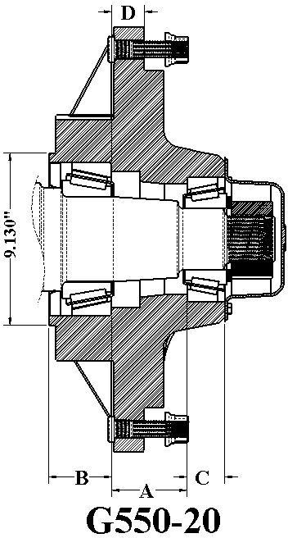

MOD | CAP LBS | HUB COMP | HUB CUPS | INNER CUP | OUTER CUP | INNER CONE | BORE DIA. | OUTER CONE | BORE DIA. | HUB CAP | STUD NUT | SEAL | A | B | C | D
G550-20 | 55000 | G289194 | G289193 | G910400 930 | G910405 832 | G910401 938 | 4.50 | G910406 842 | 3.25 | G909924 | G913475 G913480 | G946550 | 4.00 | 3.33 | 2.00 | 1.63
*Hub Capacity Based On 1.50" Offset.*
*Bolt Pattern For Brake Version Hub Is 10 On 11.00" B.C. (1/2-20 UNF).*
*G550-20 Hub Is Made From Ductile Material*

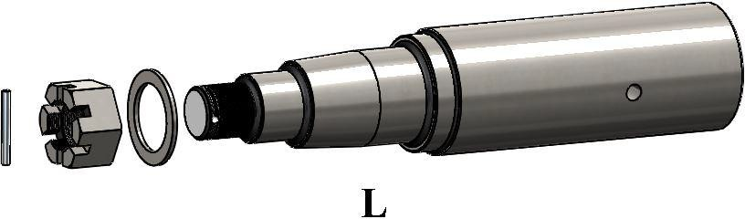

FITS MOD  # | MAT’L | MAT’L  DIA. | SPINDLE  PACKAGE | SPINDLE  ONLY | WASHER | NUT | PIN | OVERALL  LENGTH | THREAD | SEAL  DIA.
G550-20 | 4140/1144 | 6.00" | G281939 | G281938 | G913640 | G912978 | G905959 | 27.500" | 2-1/2-12 | 5.500

For customer specific spindle needs, please refer to the Spindle Special Order page (Page 5).

RECREATIONAL VEHICLE HUBS

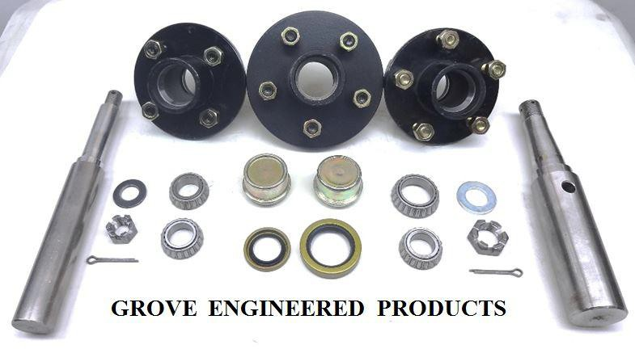

4-Bolt, 4” Bolt Circle, 2.50” Pilot
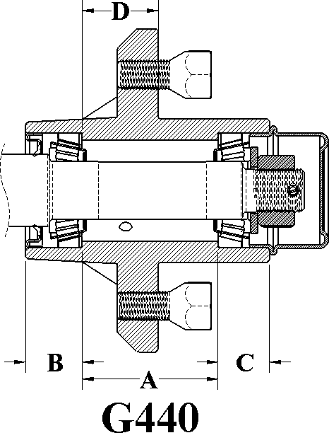
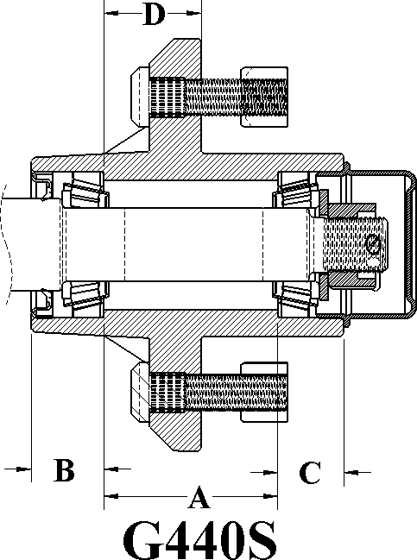

MOD | CAP LBS | HUB COMP | HUB CUPS | INNER CUP | OUTER CUP | INNER CONE | BORE DIA. | OUTER CONE | BORE DIA. | HUB CAP | BOLT STUD NUT | SEAL | A | B | C | D
G440 | 1250 | G280306 | G280301 | G910250 L44610 | G910250 L44610 | G910254 L44643 | 1.00 | G910254 L44643 | 1.00 | G909900 | G913541 | G906282 | 2.36 | .79 | .84 | 1.34
G440S | 1250 | G280316 | G280311 | G910250 L44610 | G910250 L44610 | G910254 L44643 | 1.00 | G910254 L44643 | 1.00 | G909900 | G953002 G912918 | G906282 | 2.36 | .79 | .84 | 1.34
G440H | 1350 | G280307 | G280301 | G910250 L44610 | G910250 L44610 | G910253 L44649 | 1.06 | G910253 L44649 | 1.06 | G909900 | G913541 | G906282 | 2.36 | .79 | .84 | 1.34
G440HS | 1350 | G280317 | G280311 | G910250 L44610 | G910250 L44610 | G910253 L44649 | 1.06 | G910253 L44649 | 1.06 | G909900 | G953002 G912918 | G906282 | 2.36 | .79 | .84 | 1.34
*Hubs Capacity Based On 0.0" Offset*
*Hubs G440H, G440HS Uses1-1/16" Inner And Outer Cones.*

FITS  MOD # | MAT’L | MAT’L  DIA. | SPINDLE  PACKAGE | SPINDLE  ONLY | WASHER | NUT | PIN | OVERALL  LENGTH | THREAD | SEAL  DIA.
G440 | CRS | 1.25" | G280799 | G280768 | G913608 | G912953 | G905935 | 8.500" | 3/4-16 | 1.250
G440 | CRS | 1.25" | G280770 | G280769 | G951801 | G953005 | G905936 | 12.000" | 1-14 | 1.250
G440 | CRS | 1.50" | G280756 | G280755 | G913608 | G912953 | G905935 | 10.000" | 3/4-16 | 1.250

For customer specific spindle needs, please refer to the Spindle Special Order page (Page 5).

5-Bolt, 4.50” Bolt Circle, 2.50” Pilot

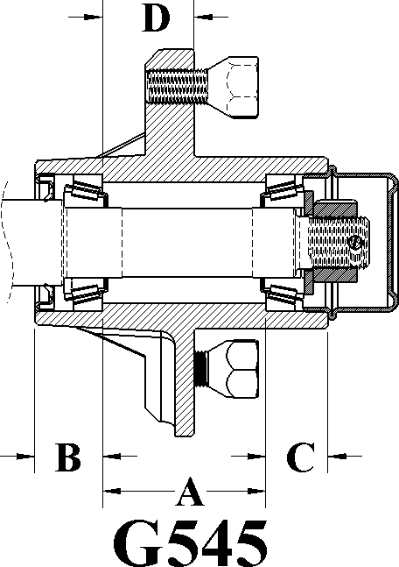
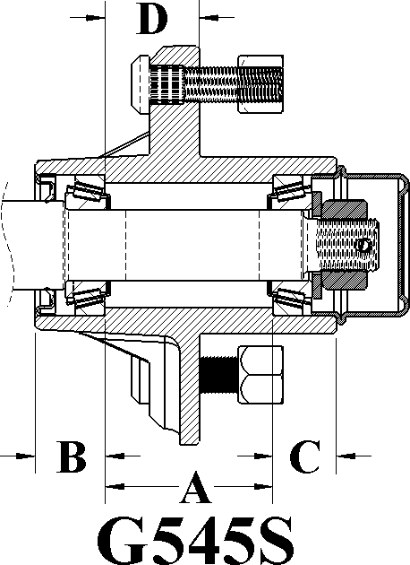

MOD | CAP LBS | HUB COMP | HUB CUPS | INNER CUP | OUTER CUP | INNER CONE | BORE DIA. | OUTER CONE | BORE DIA. | HUB CAP | BOLT STUD NUT | SEAL | A | B | C | D
G545 | 1250 | G280266 | G280261 | G910250 L44610 | G910250 L44610 | G910254 L44643 | 1.00 | G910254 L44643 | 1.00 | G909900 | G913541 | G906282 | 2.36 | .79 | .84 | 1.34
G545S | 1250 | G280286 | G280281 | G910250 L44610 | G910250 L44610 | G910254 L44643 | 1.00 | G910254 L44643 | 1.00 | G909900 | G953002 G912918 | G906282 | 2.36 | .79 | .84 | 1.34
G545H | 1350 | G280267 | G280261 | G910250 L44610 | G910250 L44610 | G910253 L44649 | 1.06 | G910253 L44649 | 1.06 | G909900 | G913541 | G906282 | 2.36 | .79 | .84 | 1.34
G545HS | 1350 | G280287 | G280281 | G910250 L44610 | G910250 L44610 | G910253 L44649 | 1.06 | G910253 L44649 | 1.06 | G909900 | G953002 G912918 | G906282 | 2.36 | .79 | .84 | 1.34

*Hub Capacity Based On 0.0” Offset.*
*Hubs G545H, G545HS Uses1-1/16" Inner And Outer Cones.*

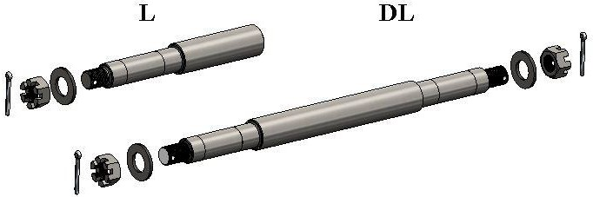

FITS MOD # | MAT’L | MAT’L DIA. | SPINDLE PACKAGE | SPINDLE ONLY | WASHER | NUT | PIN | OVERALL LENGTH | THREAD | SEAL DIA.
G545 | CRS | 1.25" | G280799 | G280768 | G913608 | G912953 | G905935 | 8.500" | 3/4-16 | 1.250
G545 | CRS | 1.25" | G280770 | G280769 | G951801 | G953005 | G905936 | 12.000" | 1-14 | 1.250
G545 | CRS | 1.50" | G280756 | G280755 | G913608 | G912953 | G905935 | 10.000" | 3/4-16 | 1.250

For customer specific spindle needs, please refer to the Spindle Special Order page (Page 5).

5-Bolt, 4.5”, 5" Bolt Circle, 2.50” Pilot
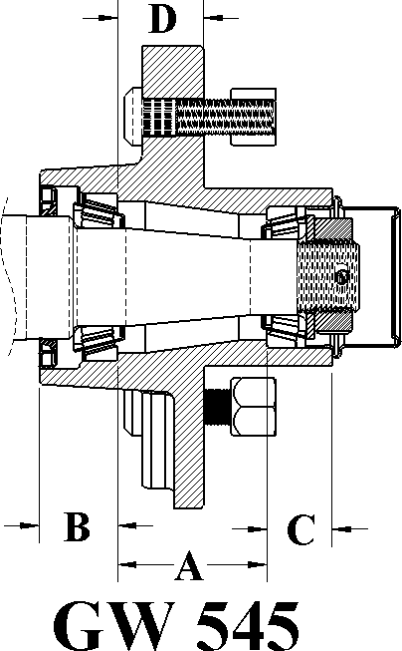
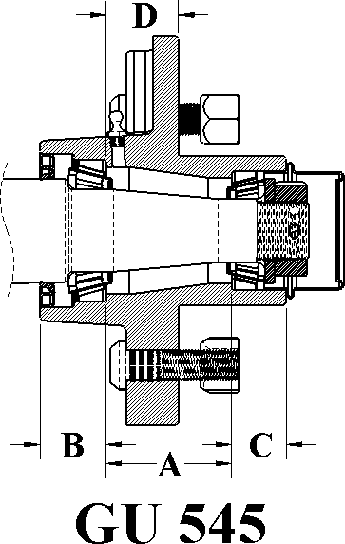
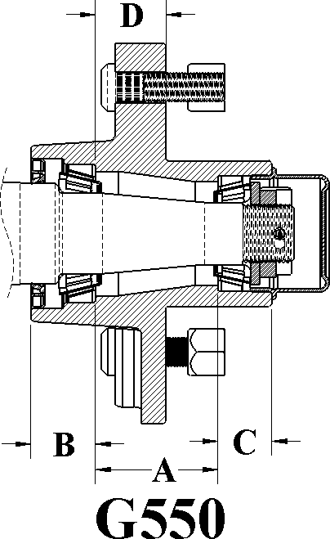

MOD | CAP LBS | HUB COMP | HUB CUPS | INNER CUP | OUTER CUP | INNER CONE | BORE DIA. | OUTER CONE | BORE DIA. | HUB CAP | BOLT STUD NUT | SEAL | A | B | C | D
GW545 | 1750 | G280040 | G280030 | G910251 L68111 | G910250 L44610 | G910252 L68149 | 1.38 | G910253 L44649 | 1.06 | G909900 | G953002 G912918 | G906282 G906281 | 2.10 | .92 | .1.10 | 1.21
GU545 | 1750 | G280090 | G280080 | G910251 L68111 | G910250 L44610 | G910252 L68149 | 1.38 | G910253 L44649 | 1.06 | G909900 | G953002 G912918 | G906281 | 2.10 | .92 | .1.10 | 1.21
G550 | 1750 | G280082 | G280083 | G910251 L68111 | G910250 L44610 | G910252 L68149 | 1.38 | G910253 L44649 | 1.06 | G909900 | G953002 G912918 | G906281 | 2.10 | .92 | .1.10 | 1.21
*HUB CAPACITY BASED ON A 0.0" OFFSET*
*GW545- SMALL FLANGE DIAMETER OF 5-9/16", USED ON 12" WHEELS AND UNDER. 4.50" B.C.*
*GU545- LARGE FLANGE DIAMETER OF 6-1/2", USED ON 13" WHEELS AND UP. 4.50" B.C.*
*G550-- LARGE FLANGE DIAMETER OF 6-1/2", USED ON 13" WHEELS AND UP. 5.50" B.C.*

FITS MOD # | MAT’L | MAT’L DIA. | SPINDLE PACKAGE | SPINDLE ONLY | WASHER | NUT | PIN | OVERALL LENGTH | THREAD | SEAL DIA.
GW545 GU545  G550 | CRS | 1.750" | G280745 G286928 | G280735 G286929 | G913608 G951801 | G912953 G953005 | G905935 G905936 | 8.375"  12.000" | 3/4-16  1-14 JAM | 1.719"

For customer specific spindle needs, please refer to the Spindle Special Order page (Page 5).

6 Bolt, 5.50” B.C. 3.55” Pilot - 8-Bolt, 6.50” B.C. 4.55” Pilot

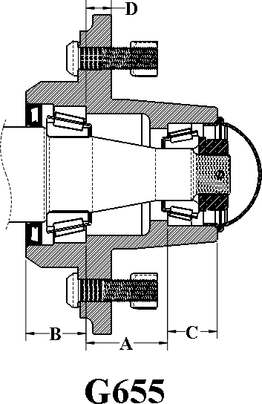
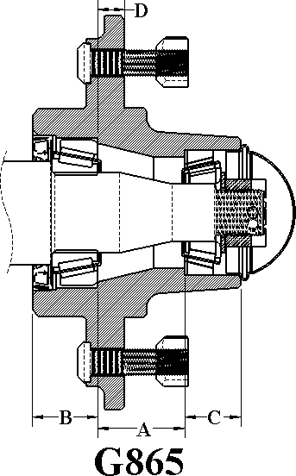

MOD | CAP LBS | HUB COMP | HUB CUPS | INNER CUP | OUTER CUP | INNER CONE | BORE DIA. | OUTER CONE | BORE DIA. | HUB CAP | BOLT STUD NUT | SEAL | A | B | C | D
G655 | 3000 | G280188 | G280187 | G910265 25520 | G910340 15245 | G910267 25580 | 1.75" | G910380 15123 | 1.25" | G909905 | G953002 G912918 | G946975 | 1.94 | 1.43 | 1.18 | .60
G865 | 3500 | G280196 | G280195 | G910265 25520 | G910290 14276 | G910267 25580 | 1.75" | G910291 14137A | 1.38" | G909926 | G913548 G913549 | G946975 | 1.89 | 1.41 | 1.22 | .83
*HUB CAPACITY BASED ON A 0.0" OFFSET*

FITS  MOD # | MAT’L | MAT’L  DIA. | SPINDLE  PACKAGE | SPINDLE  ONLY | WASHER | NUT | PIN | OVERALL  LENGTH | THREAD | SEAL  DIA.
G655 | CRS | 2.250" | G280794 | G280793 | G913622 | G953005 | G905936 | 8.250" | 1-14 UNF | 2.250"
G865 | CRS | 2.250" | G280796 | G280795 | G913622 | G912005 | G905936 | 9.500" | 1-14 UNF | 2.250"

For customer specific spindle needs, please refer to the Spindle Special Order page (Page 5).

SPECIALTY HUBS

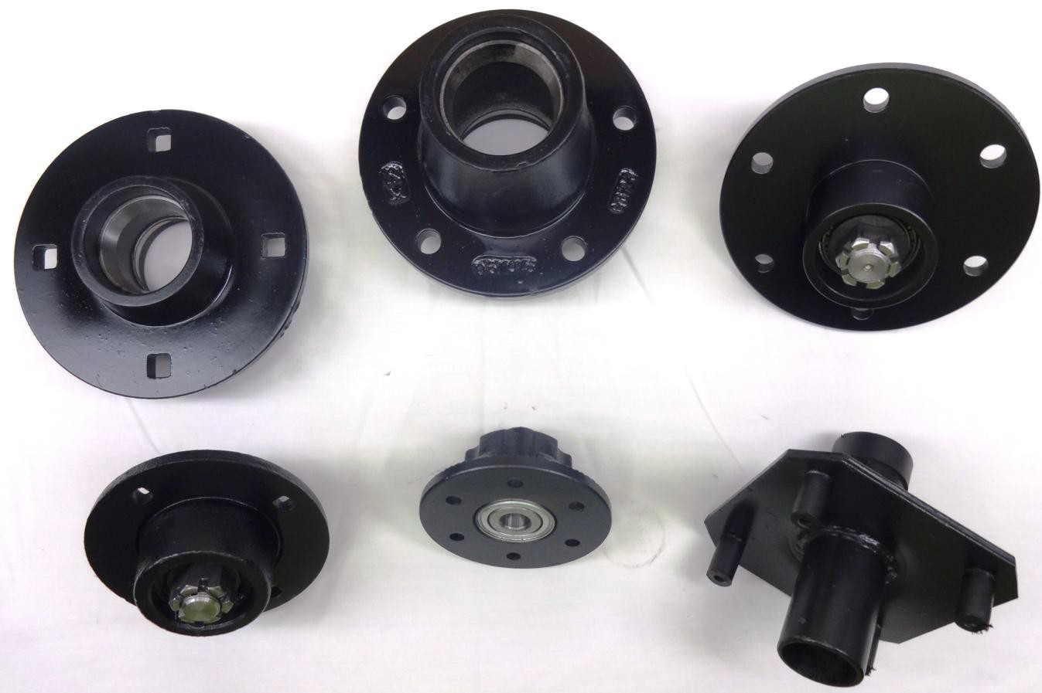

5-Bolt, 5.5” Bolt Circle, 4” Pilot

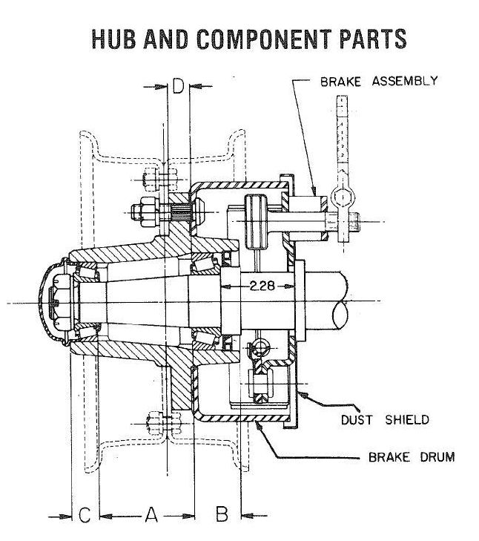

G623

MOD | CAP LBS | HUB COMP | HUB CUPS | INNER CUP | OUTER CUP | INNER CONE | BORE DIA. | OUTER CONE | BORE DIA. | HUB CAP | STUD NUT | SEAL | A | B | C | D
G623 | 3180 | G286590 | G286591 | G910381 24720 | G910340 15245 | G910349 24780 | 1.63 | G910380 15123 | 1.25 | G909905 | G943538 G912925 | TBA | 2.91 | 1.44 | 0.84 | 0.69

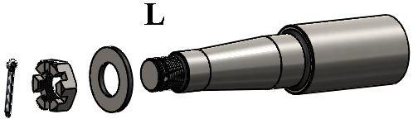

FITS MOD # | MAT’L | MAT’L DIA. | SPINDLE PACKAGE | SPINDLE ONLY | WASHER | NUT | PIN | OVERALL LENGTH | THREAD | SEAL DIA.
G623 | CRS | 2.125" | G280726 | G280725 | G913622 | G953005 | G90542 | 9.00 | 1-14 UNF | 2.125"
For customer specific spindle needs, please refer to the Spindle Special Order page (Page 5).
For customer specific spindle needs, please refer to the Spindle Special Order page (Page 5).

Coulter Hubs
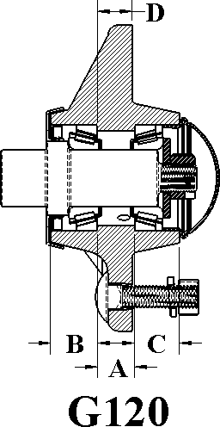
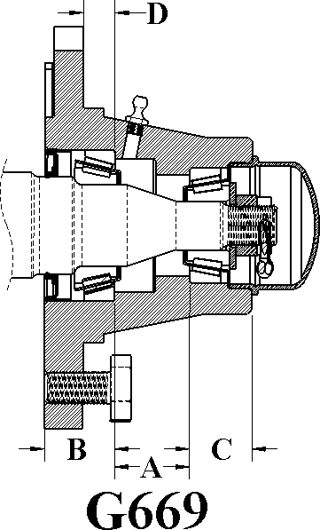
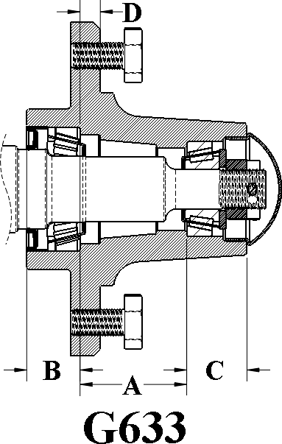

MOD | CAP LBS | HUB COMP | HUB CUPS | INNER CUP | OUTER CUP | INNER CONE | BORE DIA. | OUTER CONE | BORE DIA. | HUB CAP | BOLT STUD NUT | SEAL | A | B | C | D
G120 | 1200 | G280023 | G280022 | G910257 LM67010 | G910257 LM67010 | G910259 LM67048 | 1.25 | G910259 LM67048 | 1.25 | G909970 | GC4060 GC4013 | G906293 | .81 | 1.00 | .81 | 1.68
G669 | 1250 | G280610 | G280611 | G910257 LM67010 | G910258 LM11910 | G910259 LM67048 | 1.25 | G910260 LM11949 | 0.75 | G909931 | G913536 | G906296 | 1.16 | 0.94 | 0.88 | 0.38
G633 | 1500 | G280500 | G280501 | G910257 LM67010 | G910258 LM11910 | G910259 LM67048 | 1.25 | G910260 LM11949 | 0.75 | G909911 | G913536 | G906296 | 2.00 | 1.00 | 1.12 | 0.38

FITS  MOD # | MAT’L | MAT’L  DIA. | SPINDLE  PACKAGE | SPINDLE  ONLY | WASHER | NUT | PIN | OVERALL  LENGTH | THREAD | SEAL  DIA.
G120 | CRS | 1 5/8" | G286021 | G286022 | G913611 | G912954 | G905937 | 4.312" | 5/8-18" | 1.500
G669 | CRS | 1-5/8" | G280772 | G280771 | G913615 | G912954 | G905937 | 10.000" | 5/8-18" | 1.500
G633 | CRS | 1-5/8" | G280772 | G280771 | G913615 | G912954 | G905937 | 10.000" | 5/8-18" | 1.500
For customer specific spindle needs, please refer to the Spindle Special Order page (Page 5).

Sealer, Row Marker Hubs

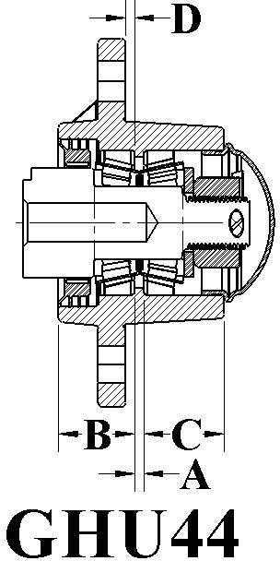
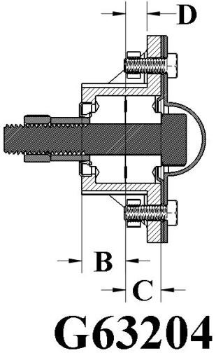
4-BOLT, 4.00" B.C. 5-BOLT, 3.00" B.C.

MOD | CAP LBS | HUB COMP | HUB CUPS | INNER CUP | OUTER CUP | INNER CONE | BORE DIA. | OUTER CONE | BORE DIA. | HUB CAP | BOLT STUD NUT | SEAL | A | B | C | D
GHU44 | 1200 | G280266 | G280261 | G910250 L44610 | G910250 L44610 | G910254 L44643 | 1.00 | G910254 L44643 | 1.00 | G909965 | G913541 | G906282 | 2.36 | .79 | .84 | 1.34
GC63204 | 1000 | TBA | TBA | N/A | N/A | G204RY2 | 1.78 | G204RY2 | 1.78 | G63204- DC | N/A | G906270 | 2.36 | .79 | .84 | 1.34

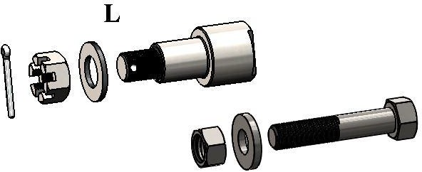

FITS  MOD # | MAT’L | MAT’L  DIA. | SPINDLE  PACKAGE | SPINDLE  ONLY | WASHER | NUT | PIN | OVERALL  LENGTH | THREAD | SEAL  DIA.
GH44 | CRS | 1.500 | GHU44SPDL | GHU44SPDL1 | G913608 | G912953 | G905935 | 3.125" | 3/4-16 | 1.500
G63204 | GRD8 | TBA | TBA | 5/8" BOLT | 5/8-LOCK | 5/8" | NO PIN | N/A | 5/8-16 | N/A
For customer specific spindle needs, please refer to the Spindle Special Order page (Page 5).

6-BOLT HAY RAKE HUBS

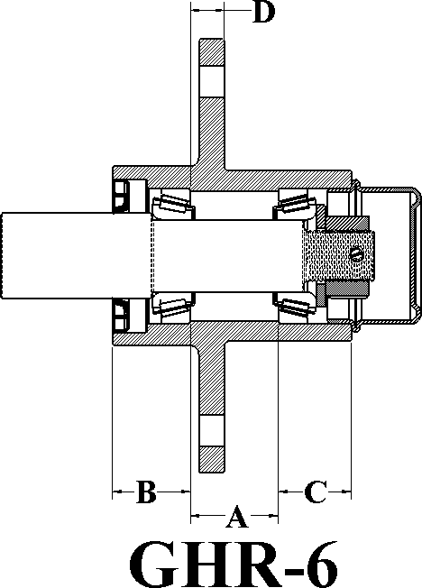
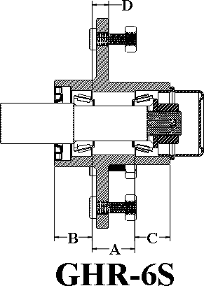

MOD | CAP LBS | HUB COMP | HUB CUPS | INNER CUP | OUTER CUP | INNER CONE | BORE DIA. | OUTER CONE | BORE DIA. | HUB CAP | BOLT STUD NUT | SEAL | A | B | C | D
GHR-6 | 1250 | G508423 | G508141 | G910250 L44610 | G910250 L44610 | G910253 L44649 | 1.98 | G910253 L44649 | 1.98 | G909965 | N/A | G906280 | 1.29 | 1.07 | 1.14 | 1.17
GHR-6S | 1250 | G508424 | G508142 | G910250 L44610 | G910250 L44610 | G910253 L44649 | 1.98 | G910253 L44649 | 1.98 | G909965 | N/A | G906280 | 1.29 | 1.07 | 1.14 | 1.17

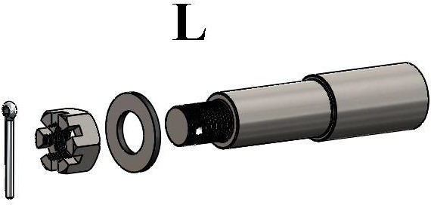

FITS MOD # | MAT’L | MAT’L  DIA. | SPINDLE  PACKAGE | SPINDLE  ONLY | WASHER | NUT | PIN | OVERALL  LENGTH | THREAD | SEAL  DIA.
GHR-6 | CRS | 1.250 | G280764 | G280763 | G913608 | G912953 | G905935 | 5.460" | 3/4-16 | 1.250
GHR-6S | CRS | 1.250 | G280764 | G280763 | G913608 | G912953 | G905935 | 5.460" | 3/4-16 | 1.250

For customer specific spindle needs, please refer to the Spindle Special Order page (Page 5).

STRADDLE HUBS

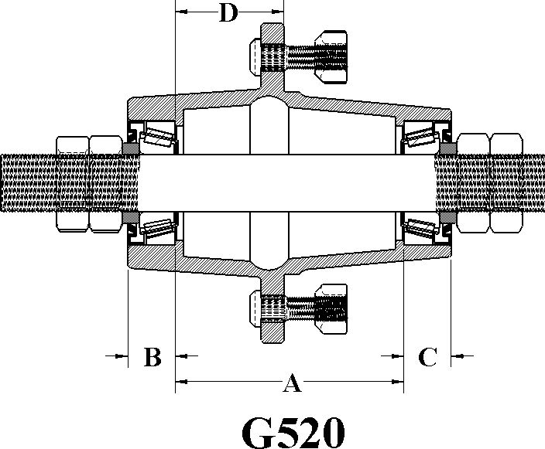
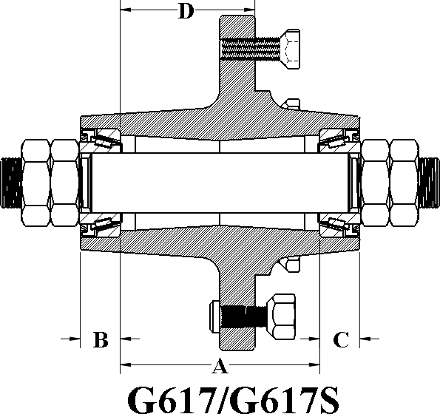

*Upon Request Only*

MOD | CAP LBS | HUB COMP | HUB CUPS | INNER CUP | OUTER CUP | INNER CONE | BORE DIA. | OUTER CONE | BORE DIA. | STUD NUT | BOLT | SEAL | A | B | C | D
G520 | 3,000 | G281088 | G281078 | G910920 14276 | G910920 14276 | G910270 14136A | 1.38 | 14136A | 1.38 | G913550 G913549 | G943549 | G906282 | 5.00 | 1.03 | 1.03 | 2.38
G617 | 3500 | G281960 | G281950 | G910377 13621 | G910377 13621 | G910379 13686 | 1.50 | G910379 13686 | 1.50 | N/A | G913555 | G946296 | 5.00 | 1.06 | 1.00 | 1.65
G617S | 3500 | G281980 | G281981 | G910377 13621 | G910377 13621 | G910379 13686 | 1.50 | G910379 13686 | 1.50 | G913550 G913549 | N/A | G946296 | 5.00 | 1.06 | 1.00 | 1.65

*Hub Capacity for G520 Is .25" Negative Offset The G617 Has A 1.12" Positive Offset*
*G520/G617 Hubs Complete Come With 2 Seals*
*G520/G617 Hub Seal Rides On The Bearing Flange*

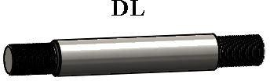

FITS MOD # | MAT’L | MAT’L  DIA. | SPINDLE  PACKAGE | SPINDLE  ONLY | SHOULDER  NUT | NUT | OVERALL  LENGTH | THREAD | SEAL  DIA.
G520 | CRS | 1.375" | G281380 | G281370 | JAM NUT | G912903 | 10.000" | 1-1/4-12 | 1.750"
G617 | CRS | 1.500" | G287590 | G287591 | JAM NUT | G912903 | 11.000" | 1-1/4-12 | 2.710"

For customer specific spindle needs, please refer to the Spindle Special Order page (Page 5).

TAIL WHEEL HUBS
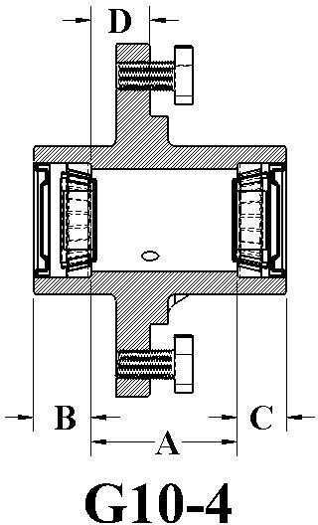
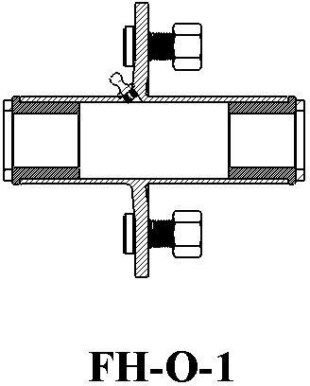
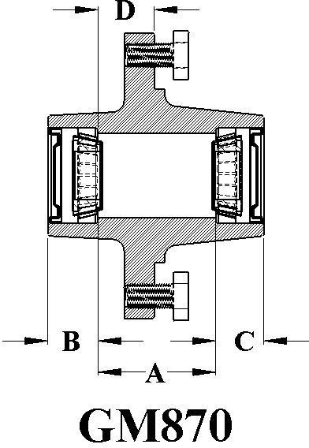

MOD | CAP LBS | HUB COMP | HUB CUPS | INNER CUP | OUTER CUP | INNER CONE | BORE DIA. | OUTER CONE | BORE DIA. | HUB CAP | BOLT | SEAL | A | B | C | D
G10-4 | 1000 | G281100 | G281101 | G910250 L44610 | G901250 L44610 | G910254 L44643 | 1.00 | G910254 L44643 | 1.00 | G909900 | G943549 | G906282 | 2.53 | 0.85 | 1.00 | 0.38
FH-O-1 | TBA | TBA | TBA | TBA | TBA | TBA | TBA | TBA | TBA | TBA | TBA | TBA | / | / | / | /
GM870 | 1250 | G286590 | G286591 | G910250 L44610 | G910250 L44610 | G910254 L44643 | 1.00 | G910254 L44643 | 1.00 | N/A | G913536 | G906282 2 QTY | 2.45 | 1.04 | 1.00 | 1.17

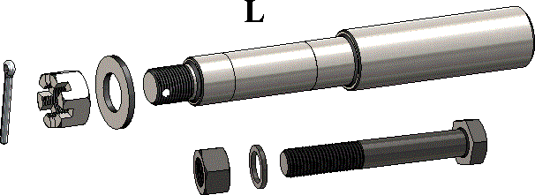

FITS MOD # | MAT’L | MAT’L DIA. | SPINDLE PACKAGE | SPINDLE ONLY | WASHER | NUT | PIN | OVERALL LENGTH | THREAD | SEAL DIA.
G10-4 | CRS | 1-1/4” | G281317 | G281280 | G910608 | G912953 | G905935 | 8.500” | ¾-16 | 1.25
GM870 | 1” BOLT TAIL WHEEL AND FORK APPLICATIONS
FH-0-1 | 1” BOLT TAIL WHEEL AND FORK APPLICATIONS
For customer specific spindle needs, please refer to the Spindle Special Order page (Page 5).

G.E.P. COMPLETE
HUB AND SPINDLE COMPONENTS

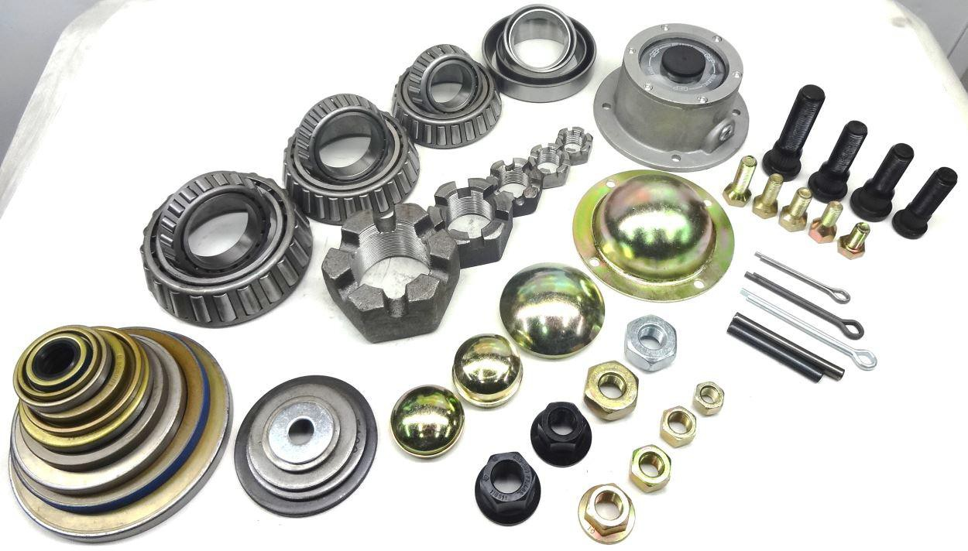

RACE / CUPS BEARINGS/CONES
GEP | IND. # | O.D.
G910269 | 14274 | 2.7170
G910290 | 14276 | 2.7170
G910340 | 15245 | 2.4370
G910381 | 24720 | 3.0000
G910265 | 25520 | 3.2640
G910382 | 25521 | 3.2700
G910266 | 25821 | 2.8740
G910278 | 26822 | 3.1250
G910285 | 2720 | 3.0000
G910327 | 28921 | 3.9370
G910288 | 332 | 3.1490
G910397 | 33462 | 4.6250
G910352 | 3525 | 3.4370
G910284 | 3720 | 3.6700
G910358 | 382A | 3.8110
G910331 | 39520 | 4.4370
G910332 | 453A | 4.2500
G910339 | 47620 | 3.2500
G910385 | 653 | 5.7490
G910335 | 71750 | 6.7500
G910405 | 832 | 6.6250
G910400 | 930 | 8.1250
G910384 | HM212011 | 4.8120
G910344 | HM218210 | 5.7860
G910263 | JL69310 | 2.4790
G910304 | JLM104910 | 3.2280
G910292 | JLM506810 | 3.5433
G910250 | L44610 | 1.9790
G910251 | L68111 | 2.3600
G910258 | LM11910 | 1.7800
G910274 | LM29710 | 2.5620
G910261 | LM48510 | 2.5620
G910272 | LM501310 | 2.8900
G910276 | LM603011 | 3.0610
G910298T | LM603012 | 3.0620
G910257 | LM67010 | 2.3270

GEP | IND. # | I.D.
G910270 | 14136A | 1.380
G910291 | 14137A | 1.380
G910380 | 15123 | 1.250
G910349 | 24780 | 1.620
G910342 | 25580 | 1.750
G910267 | 25590 | 1.790
G910268 | 25877 | 1.380
G910279 | 26882 | 1.625
G910287 | 2790 | 1.310
G910367 | 2793 | 1.375
G910326 | 28995 | 2.470
G910398 | 33275 | 2.750
G910289 | 342A | 1.620
G910355 | 3585 | 1.625
G910286 | 3780 | 2.000
G910359 | 387AS | 2.250
G910333 | 39585 | 2.500
G910334 | 460 | 1.750
G910338 | 47687 | 3.250
G910351 | 633 | 3.250
G910350 | 71455 | 4.531
G910401 | 938 | 4.500
G910406 | 842 | 3.250
G910347 | HM212049 | 2.620
G910346 | HM218248 | 3.540
G910264 | JL69349 | 1.500
G910305 | JLM104948 | 1.968
G910293 | JLM506849 | 2.165
G910254 | L44643 | 1.000
G910253 | L44649 | 1.060
G910252 | L68149 | 1.380
G910260 | LM11949 | 0.750
G910275 | LM29749 | 1.500
G910262 | LM48548 | 1.380
G910273 | LM501349 | 1.620
G910277 | LM603049 | 1.780
G910259 | LM67048 | 1.250

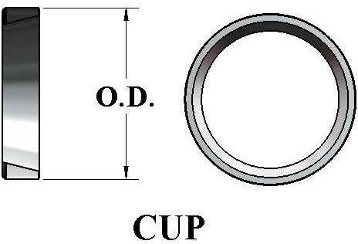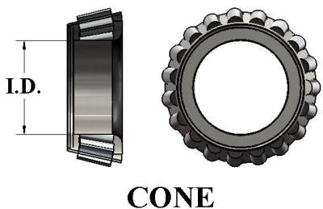

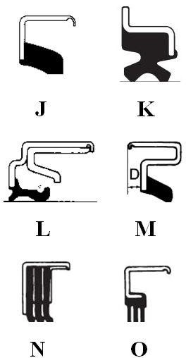
NOTE:
MOST OF OUR SEALS ARE AVAILABLE IN A GREASED OR OIL BATH VERSION. THUS ALOWING YOU TO CUSTOMIZE ALL YOUR SEALING NEEDS AND REQUIREMENTS.
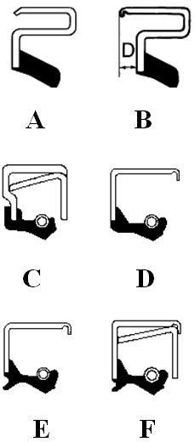GREASE SEALS

GEP # | CR# | TYPE | SHAFT | BORE | WIDTH
37605SA | N/A | E | 3.750 | 6.000 | 0.500
G906270 | N/A | D | 0.875 | 1.499 | 0.250
G906280 | 12582 | B | 1.250 | 2.250 | 0.250
G906281 | 17146 | B | 1.719 | 2.652 | 0.500
G906282 | 12437 | A | 1.250 | 1.983 | 0.250
G906283 | 15190 | A | 1.500 | 2.623 | 0.250
G906284 | 16289 | B | 1.625 | 2.562 | 0.438
G906285 | 20148 | A | 2.000 | 3.623 | 0.250
G906287 | 16290 | D | 1.625 | 2.561 | 0.313
G906293 | 16069 | B | 1.625 | 2.328 | 0.438
G906294 | 20044 | A | 2.000 | 3.061 | 0.250
G906295 | 17617 | B | 1.750 | 2.718 | 0.359
G906296 | 14975 | B | 1.500 | 2.328 | 0.390
G906297 | 22392 | A | 2.250 | 3.061 | 0.250
G906301 | 19785 | D | 2.000 | 2.716 | 0.375
G906479 | 13812 | E | 1.375 | 2.440 | 0.313
G906481 | 25091 | C | 2.500 | 3.751 | 0.438
G906484 | 12411 | A | 1.250 | 1.979 | 0.406
G906486 | 27394 | A | 2.750 | 3.751 | 0.250
G906487 | 22870 | B | 2.297 | 3.148 | 0.359
G906489 | 27361 | D | 2.750 | 3.751 | 0.438
G906490 | 17404 | D | 1.750 | 2.561 | 0.313
G906493 | 18823 | A | 1.875 | 3.000 | 0.250
G906494 | 12428 | E | 1.250 | 1.983 | 0.250
G906495 | 20125 | F | 2.000 | 3.371 | 0.438
G906497 | 30087 | C | 3.000 | 4.500 | 0.438
G906979 | 43771 | C | 4.375 | 6.001 | 0.500
G906981 | 11164 | B | 1.125 | 1.781 | 0.496
G906982 | 21208 | A | 1.125 | 3.061 | 0.250
G906984 | 35062 | L | 3.500 | 4.842 | 0.906
G906985 | 22368 | C | 2.250 | 3.000 | 0.250
G906998 | 29273 | E | 2.938 | 3.937 | 0.438
G946275 | 33772 | C | 3.375 | 4.626 | 0.438
G946278 | 16064 | O | 1.625 | 2.328 | 0.438
G946290 | 20045 | D | 2.000 | 3.061 | 0.375
G946484 | 29925 | F | 3.00 | 4.003 | 0.438
G946486 | 29968 | A | 3.000 | 4.003 | 0.250
G946492 | 24904 | A | 2.500 | 3.251 | 0.250
G946498 | 38730 | C | 3.875 | 5.251 | 0.438
G946499 | 55179 | C | 5.500 | 7.501 | 0.563
G946500 | 38731 | F | 5.404 | 8.135 | 0.625
G946503 | 39320 | C | 3.938 | 5.521 | 0.438
G946550 | N/A | E | 6.000 | 8.122 | 0.500
G946975 | 22558 | C | 2.250 | 3.371 | 0.438
G950296 | 14977 | E | 1.500 | 2.328 | 0.500
G906999 | 29273 | E | 2.938 | 3.937 | 0.438
G946490 | 53056 | F | 1.500 | N/A | N/A

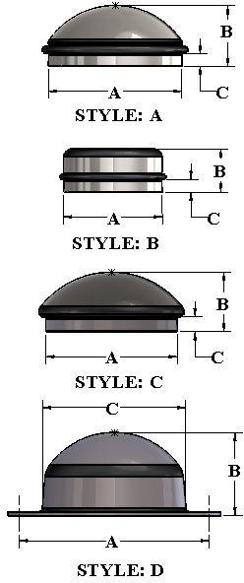HUB CAPS

GEP | TYPE | MAT'L THK | DIM A | DIM B | DIM C | PLATE
G909931 | B | 0.060 | 1.942 | 1.375 | 0.281 | NP/P/Z
G909907 | A | 0.037 | 1.943 | 1.380 | 0.340 | NP/P/Z
G909911 | C | 0.060 | 1.956 | .9370 | 0.312 | NP/P/Z
G909965 | A | 0.060 | 1.982 | 1.000 | 0.313 | NP/P/Z
G909900 | B | 0.060 | 1.986 | 1.250 | 0.375 | NP/P/Z
G909908 | B | 0.050 | 2.328 | 1.250 | 0.300 | NP/P/Z
G909970 | A | 0.074 | 2.334 | 1.187 | 0.250 | NP/P/Z
G909902 | B | 0.040 | 2.446 | 1.280 | 0.240 | NP/P/Z
G909905 | A | 0.074 | 2.448 | 1.120 | 0.250 | NP/P/Z
G909927 | B | 0.060 | 2.570 | 1.323 | 0.272 | NP/P/Z
G909928 | C | 0.074 | 2.718 | 0.930 | 0.437 | NP/P/Z
G909926 | A | 0.036 | 2.720 | 1.437 | 0.313 | NP/P/Z
G909912 | C | 0.060 | 3.125 | 1.310 | 0.375 | NP/P/Z
G909982 | A | 0.065 | 3.160 | 1.440 | 0.303 | NP/P/Z
G909930 | A | 0.074 | 3.950 | 2.126 | 0.313 | NP/P/Z
G909980 | D | 0.130 | 4.875 | 2.060 | 0.402 | NP/P/Z
G909983 | D | 0.060 | 5.000 | 1.750 | 3.930 | NP/P/Z
G909921 | D | 0.104 | 5.500 | 1.910 | 4.340 | NP/P/Z
G909920 | D | 0.130 | 6.000 | 4.560 | 2.63 | NP/P/Z
G909922 | D | 0.080 | 7.000 | 2.432 | 5.890 | NP/P/Z
G909924 | D | 0.130 | 7.500 | 3.125 | 6.250 | NP/P/Z

OIL BATH DUST CAPS
FINISH:
Z = ZINC PLATED P = PAINTED
NP = NON PLATED
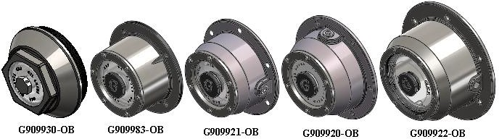

OIL BATH/DUST CAP GASKETS

GEP # | BOLT CIRCLE | NO. OF BOLTS | DUST CAP | OIL BATH | FITS HUB
G909980G | 4.875" | 4 | X-4-BOLT | N/A | G108
G909983G | 5.000" | 4 & 6 | X-4-BOLT | X-4-BOLT | G871/G873
G909920G | 6.000" | 4 & 6 | X-4-BOLT | X-6-BOLT | G900/G900HD
G909921G | 5.500" | 4 & 6 | X-4-BOLT | X-6-BOLT | G881/G891/G991
G909922G | 7.000" | 4 & 6 | X-4-BOLT | X-6-BOLT | G250-10/G300-10
G909924G | 7.500" | 8 | X-8-BOLT | N/A | G500-10/G550-20
BOLT | THREAD | DIM A | DIM B | DIM C | TYPE
G905215 | 5/16-18 UNC | 0.703" | 0.500" | .500" | HEX BOLT

WHEEL BOLTS

BOLT | TYPE | THREAD | DIM A | DIM B | DIM C | DIM D | PL | GRADE
G913535 | LUG | 5/16-18 | 1.813 | .875 | 15/16 | 0 | PL | 5
G913536 | LUG | 1/2-20 | 1.344 | 0.906 | 13/16 | 0 | PL | 8
G913541 | LUG | 1/2-20 | 1.625 | 0.906 | 13/16 | 60 | PL | 5
G913539 | LUG | 1/2-20 | 1.500 | 1.000 | 3/4 | 90 | PL | 5
G943549 | LUG | 1/2-20 | 1.750 | 1.250 | 13/16 | 90 | PL | 5
G913538 | LUG | 9/16-18 | 1.625 | 1.125 | 7/8 | 90 | PL | 5
G913555 | LUG | 9/16-18 | 2.000 | 1.500 | 7/8 | 90 | PL | 5
G953027 | LUG | 5/8-18 | 2.000 | 1.375 | 15/16 | 90 | PL | 5

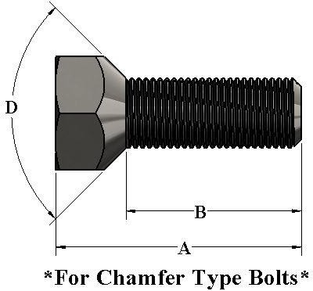
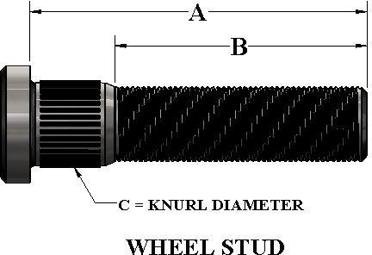
WHEEL STUDS AND NUTS
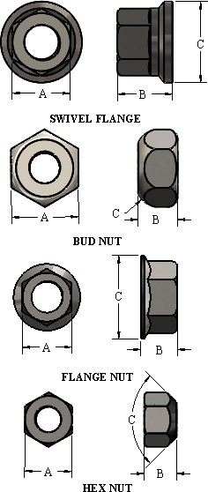
STUD | THD | DIM A | DIM B | DIM C | PL | GRADE
G943538 | 1/2-20 | 1.880 | 1-9/32 | .5380 | PL | J1102
G953002 | 1/2-20 | 1-7/8 | 1-1/4 | .5380 | PL | J1102
G913576 | 1/2-20 | 1-7/8 | 1-5/16 | .6150 | NP | J1102
G913574 | 1/2-20 | 1-5/8 | 1-1/8 | .6150 | NP | J1102
G913569 | 1/2-20 | 2-1/8 | 1-5/8 | .6150 | NP | J1102
G913551 | 9/16-18 | 2-1/2 | 1-3/4 | .6150 | NP | GR5
G913548 | 9/16-18 | 2-1/8 | 1-13/16 | .6150 | NP | GR5
G913552 | 9/16-18 | 3.000 | 2-1/4 | .6150 | NP | GR5
G943542 | 5/8-18 | 2-3/4 | 1-7/8 | .6800 | PL | GR5
G943541 | 5/8-18 | 2-1/2 | 1-5/8 | .6800 | PL | GR5
G943527 | 5/8-18 | 2-3/8 | 1-5/8 | .6800 | PL | GR5
G913556 | 5/8-18 | 2-1/4 | 1-1/2 | .6800 | PL | GR5
G953021 | 3/4-16 | 2-5/8 | 1-13/16 | .8120 | PL | GR5
G953033 | 3/4-16 | 2-13/16 | 1-13/16 | 1.007 | PL | GR5
G913564 | 3/4-16 | 2-9/16 | 1-9/16 | 1.007 | PL | GR5
G953034 | 3/4-16 | 3-55/64 | 2-1/2 | 1.007 | PL | GR5
G953035 | 3/4-16 | 3-1/2 | 3-1/2 | 1.007 | PL | GR5
G953036 | 3/4-16 | 3.000 | 3.000 | 1.007 | PL | GR5
G913472 | M22 - 1.5 | 90mm | 2-1/2 | 1.007 | PL | GR5
G913475 | M22 - 1.5 | 100mm | 3.000 | 1.007 | PL | GR5
NUT | THD | DIM A | DIM B | DIM C | PL | TYPE
G912918 | 1/2-20 | 13/16 | 5/8 | 60 | PL | HEX
G912919 | 1/2-20 | 13/16 | 5/8 | 90 | PL | HEX
G912926 | 1/2-20 | 3/4 | 9/16 | 1.00 | PL | FLG
G913549 | 9/16-18 | 1.00 | 11/16 | 60 | PL | HEX
G913549 | 9/16-18 | 1.00 | 11/16 | 90 | PL | HEX
G912938 | 9/16-18 | 1.00 | 11/16 | 1.30 | PL | FLG
G912936 | 5/8-18 | 15/16 | 5/8 | 1.30 | PL | FLG
G913557 | 5/8-18 | 15/16 | 23/32 | 90 | PL | HEX
G953017 | 5/8-18 | 15/16 | 23/32 | 90 | PL | HEX
G912935 | 3/4-16 | 1-1/2 | 7/8 | RAD | PL | BUD
G913571 | 3/4-16 | 1-1/8 | 3/4 | 1.50 | PL | FLG
G913490 | 3/4-16 | 1-1/4 | 1.10 | 1.75 | PL | SVFLG
G913480 | 22mm | 33mm | 1.23 | 1.80 | PL | SVFLG

SPINDLE NUTS

NUT | THREAD | DIM A | DIM B | DIM C | STYLE
G912932 | 1-3/4-12 | 1.500 | 1.000 | 2-31/32 | A
G912947 | 1-14 | .8750 | .5900 | 1-1/4 | B
G912952 | 7/8-14 | .7600 | .5000 | 1-5/16 | A
G912953 | 3/4-16 | .6400 | .3900 | 1-1/16 | A
G912954 | 5/8-18 | .5400 | .3200 | 15/16 | A
G912959 | 1-14 | .8700 | .5700 | 1-1/2 | A
G912961 | 1-1/4-12 | 1.000 | .5600 | 1-13/16 | A
G912962 | 1-1/4-12 | 1.090 | .6900 | 1-7/8 | A
G912969 | 1-1/4-12 | 1.250 | .8900 | 1-55/64 | A
G912973 | 2-12 | 1.270 | .7000 | 3-5/16 | A
G912975 | 2-12 | 1.720 | 1.150 | N/A | A
G912978 | 2-1/2-12 | 2.180 | 1.470 | N/A | A
G912979 | 3-12 | N/A | N/A | N/A | A
G912980 | 3-12 | 2.354 | 1.554 | N/A | A
G912980-D | 3-12 | 2.200 | 1.490 | 3-7/8 | B
G943566 | 1-1/8-12 | 1.000 | .6000 | 1-11/16 | A
G953005 | 1-14 | .5400 | .2800 | 1-1/2 | A
G953018 | 1-1/2-12 | 1.250 | .8500 | 2-3/16 | A

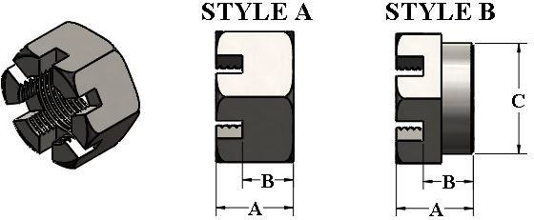
GREASE FITTINGS

COTTER PINS

PIN | FINISH | DIM A | DIM B | DIM C | NUT
G905925 | NP | .330 | 3.000 | .625 | 1-3/4
G905935 | NP | .150 | 1.500 | .340 | 3/4
G905936 | NP | .150 | 1.875 | .312 | JAM
G905937 | NP | .150 | 1.250 | .325 | 5/8
G905939 | NP | .125 | 1.000 | .227 | N/A
G905940 | NP | .150 | 2.500 | .440 | N/A
G905941 | NP | .200 | 2.250 | .440 | 1-1/4
G905942 | NP | .200 | 2.000 | .500 | 1"
G905945 | NP | .312 | 3.500 | .625 | 2"
G905957 | NP | .375 | 3.000 | ROLL | 2"
G905959 | NP | .375 | 3.500 | ROLL | 2-1/2

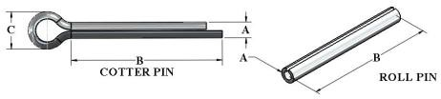

SPINDLE WASHERS
WASHER | MATL THK | DIM A | DIM B | DESCRIPTION
G913602 | 0.09 | 1.38 | 0.65 | STD
G913607 | 0.16 | 2.00 | 0.94 | STD
G913608 | 0.13 | 1.50 | 0.81 | STD
G913611 | 0.16 | 1.75 | .68 | STD
G913615 | 0.09 | 1.31 | 0.66 | STD
G913616 | 0.18 | 2.00 | 0.81 | HARDENED
G913622 | 0.13 | 2.00 | 1.06 | STD
G913624 | 0.26 | 2.13 | 1.06 | STD
G913631 | .172 | 3.00 | 1.38 | STD
G913632 | .20 | 3.25 | 1.29 | STD
G913635 | 0.25 | 4.00 | 2.06 | STD
G913637 | 0.13 | 2.50 | 1.28 | STD
G913639 | 0.25 | 3.50 | 1.80 | STD
G913640 | 0.25 | 4.50 | 2.625 | STD
G913641 | .1875 | 3.75 | 2.14 | HARDENED
G913675 | 0.16 | 2.00 | 0.94 | HARDENED
G913683 | 0.16 | 2.25 | 0.94 | STD
G951801 | 0.12 | 1.75 | 1.01 | PLATED

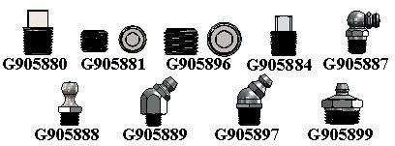
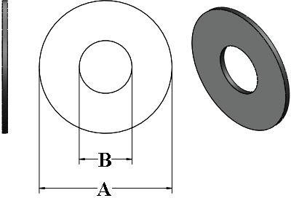
FITTING | DESCRIPTION | STYLE | ANGLE | THREAD
G905881 | ALLEN HEAD PLUG | TAP | - | 1/4-28 UNF
G905884 | EXT. SQUARE HEAD PLUG | TAP | - | 1/4-28 UNF
G905887 | GREASE FITTING | TAP | 90° | 1/4-28 UNF
G905888 | GREASE FITTING | TAP | ST | 1/4-28 NPT
G905889 | GREASE FITTING | TAP | 45° | 1/4-28 UNF
G905896 | ALLEN HEAD PLUG | TAP | - | 1/8-27 NPT
G905897 | GREASE FITTING | TAP | 45° | 1/8-27 NPT
G905899 | GREASE FITTING | TAP | ST | 1/8-27 NPT
G905880 | EXT. SQUARE HEAD PLUG | TAP | - | 1/8-27 NPT

SEGMENTED TIRES

DESCRIPTION | B.C. | OD | ID | W
4 x 8 Laminated Tire - Flat | 4 on 5.00" | 15.00" | 8.00" | 4.00"
5 x 8 Laminated Tire Crowned | 4 on 5.00" | 15.00" | 8.00" | 5.00"
6 x 9 Laminated Tire - Crowned | 5 on 5.50" | 20.00" | 9.00" | 6.00"
FORK HUBS

MODEL # | CAP LBS. | HUB COMP | HUB CUPS | BOLT CIRCLE | NO. OF BOLTS
G10-4 | 1,000 | G281100 | G281101 | 5.00" | 4-BOLT
FH-O-1 | TBA | TBA | TBA | 5.00" | 4-BOLT
GM870 | 1,250 | TWH | TWH | 5.00" | 4-BOLT

FORKS

PART # | SHAFT SIZE | BOLT SIZE | COLOR | WEIGHT
04-TW400X8-FORK1 | 1-1/2" SHAFT | 1.00" BOLT | BLACK | 17 lbs.
04-TW400X8-YOKE | 1-1/2" SHAFT | 3/4" BOLT | BLACK | 17 lbs
04-325-2604 | 1-1/4" SHAFT | 3/4" BOLT | BLACK | 16 lbs

TAIL WHEEL HUB, FORK, AND 4X8 TIRE
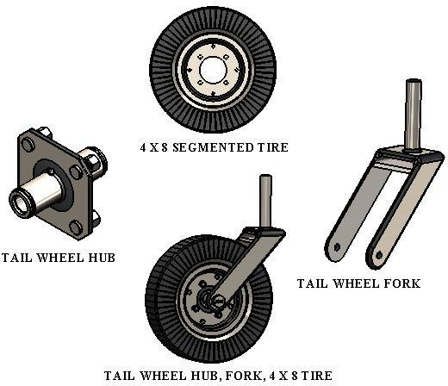

`

COULTER BLADES
20" PLAIN
20" RIPPLE
20" WAVY
17" WAVY
14" NOTCHED
20" NOTCHED

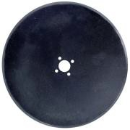 |  | 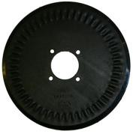 |  | 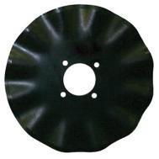 |  | 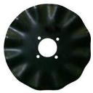 | 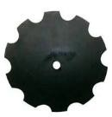 |  | 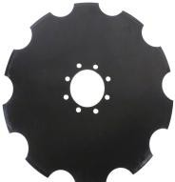
 | Part Number |  | Diameter |  | Style |  |  | Bolt Circle |  | Stocked  Item
 | G14CN.35 |  | 14" |  | CON CAVE FLAT NOTCHED |  |  | 5.2" AND 5.00" |  | NO
 | G17W12 |  | 17" |  | WAVY WITH 12-FLUTES |  |  | 5.25" AND 5.00" |  | YES
 | G20R.45 |  | 20" |  | RIPPLE |  |  | 5.25" AND 5.00" |  | YES
 | G20SE.45 |  | 20" |  | STRAIGHT EDGE RIPPLE |  |  | 5.25" AND 5.00" |  | YES
 | G20W12 |  | 20" |  | WAVY WITH 12 FLUTES |  |  | 5.25" AND 5.00" |  | YES
 | G20F.45 |  | 20" |  | PLAIN |  |  | 5.25" AND 5.00" |  | YES
 | GRC1176 |  | 22" |  | 18 BLADE SAWTOOTH |  |  | 5.25" AND 5.00" |  | NO

**OTHER SIZES AVAILABLE**
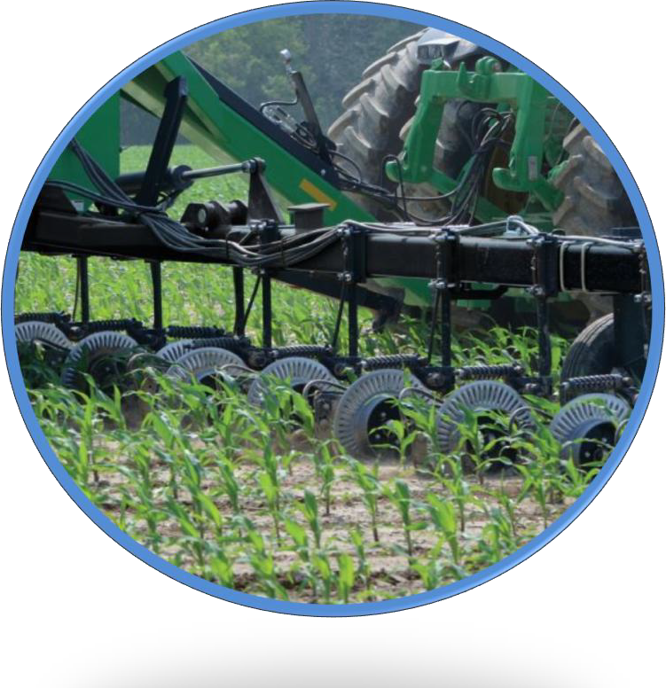
GEP APPLICATONS
- Concave (plain or notched)
- Straight
- Corrugated
- Fluted
- Customer Specific Design
All discs are manufactured from sheets of steel produced by exclusive cross rolling. This is a process that allows uniform radial wear and greater stability to the product.

SWIVEL JACKS
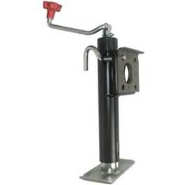

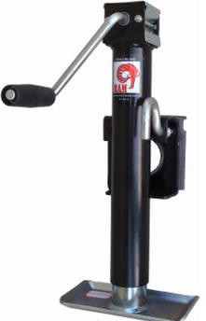

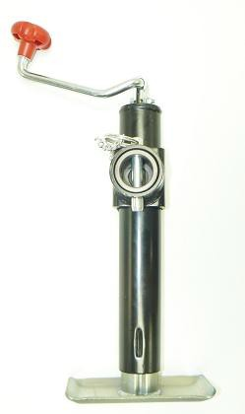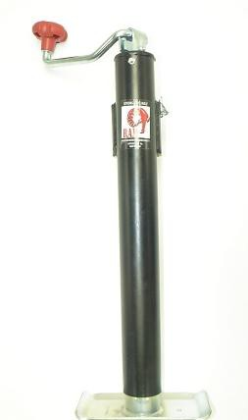TJB-2001S-B
TJB-5001-B

TKTKB
TJB-2001-B
TJD-2002-B
Part# | Capacity | Handle | Travel | Mount | Pallet
TJP-2001-B | 2000# | Top wind | 10" | Pipe | 160
TJP-2002-B | 2000# | Top Wind | 15" | Pipe | 160
TJP-2002S-B | 2000# | Side Wind | 15" | Pipe | 130
TJP-5001-B | 5000# | Top Wind | 10” | Pipe | 160
TJP-5002-B | 5000# | Top Wind | 15" | Pipe | 160
TJP-5002S-B | 5000# | Side Wind | 15" | Pipe | 120
TJB-2001-B | 2000# | Top Wind | 10" | Bracket | 160
TJB-2001S-B | 2000# | Side Wind | 10" | Bracket | 120

TOP WIND AND SIDE WIND A-FRAME JACKS
TJA-2000-B
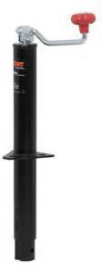
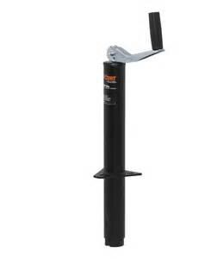
TJA-5000T-B

Part# | Capacity | Handle | Travel | Bracket Height | Pallet
TJA-2000-B | 2000# | Top Wind | 14” | 8” | 200
TJA-2001-B | 2000# | Top Wind | 14” | 5” | 200
*TJA-2002-B | 2000# | Top Wind | 15” | 9” | 200
TJA-5000-B | 5000# | Top Wind | 14” | 10.5” | 200
*TJA-5000T-B | 5000# | Top Wind | 15” | 10.5” | 200
TJA-2000S | 2000# | Side Wind | 14.5” | 9” | 160

* Are the enhanced version of regular 2000# and 5000# jacks. They are taller and constructed with thicker inner tube for greater side load.

JACKS CONTINUED
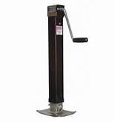
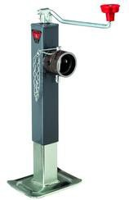
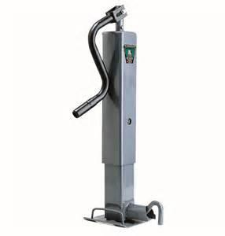
TJD-7000S TJD-5000 TJD-12000TW-R

SQUARE JACKS - DIRECT WELD

Part# | Capacity | Handle | Travel | Leg Style | Pallet
TJDP-7000S | 8000# | Side Wind | 15" | Drop Leg | 80
TJDP-7000S-FLB* | 8000# | Side Wind | 15" | Drop Leg w/ Fixed Base | 75

SQUARE JACKS PIPE MOUNT SWIVEL

Part# | Capacity | Handle | Travel | Leg Style | Pallet
TJD-5000 | 5000# | Top Wind | 15" | Drop Leg | 100
TJD-7000 | 8000# | Side Wind | 15" | Drop Leg | 90
TJD-7000S | 8000# | Side Wind | 15" | Drop Leg | 90
*FLB = Fixed Leg*

HEAVY DUTY SQUARE JACKS

Part# | Support Cap. | Lift Cap. | Handle | Travel | Pallet
*TJD-12000TW-R* | 12000# | 10000# | Top Wind | 12.5" | 30
**TJD-12000TWSP-R** | 12000# | 10000# | Top Wind | 12.5" | 30
**TJD-12000SP-R2** | 12000# | 10000# | Side Wind | 12.5" | 30
*Direct Weld - Non Spring return* **Direct Weld - with Spring Return**

